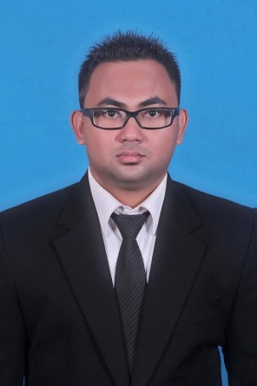
CURRICULUM VITAE
FULL NAME : OKSIANES REIN HARD BAWEMBANG
PLACE OF BIRTH : Makasar, Indonesia
DATE OF BIRTH : September 05, 1990
ADDRESS : Jl. Kebon Jeruk Raya No. 31 Rt. 002 / Rw. 09
Kel. Kebon Jeruk, Kec. Kebon Jeruk – Jakbar 11530
RELIGION : Christian
HANDPHONE : 085365079225
EMAIL : oksianesbawembang@gmail.com
NATIONALITY : Indonesia
MARITAL STATUS : Single

EDUCATION DETAILS :
Degree | University | Title of Degree | GPA | Year of Completed
Undergraduate | Satya Wacana Christian University Salatiga, Jawa Tengah | Bachelor Degree Economics / Accounting (SE) | 2.84 | 2014

ORGANIZATIONAL EXPERIENCE :
Organization Name | Subjects / Position | Years
- Leadership Outbound Training Committee | - Event Division | 2012 - 2013
- Functionaries Student Senate Faculty of Economics and Business | - Chairperson | 2011 - 2012
- Sosial Evening "LEGEND" Committee | - Sterring Committee | 2012
- Functionaries Student Senate Faculty of Economics and Business | - Secretarial Field | 2010 - 2011
- Rafting with Mitra Gahana Committee | - Equipment Division | 2010
- Celebes Cup Committee | - Chairperson | 2010
- Ethnic Harmony Board Sangihe - Talaud | - Secretary | 2009 - 2011

TRAINING :
Name of Training | Organizer / Place | Years | Predicate
Microsoft Power Point Training | Strada E & C Educational Institutions, Dumai – Riau | 2008 - 2009 | Good
Microsoft Office Training | Widya Karya Tama Educational Institutions, Dumai - Riau | 2005 - 2006 | Very Good
Basic Computer Training | Computer CAS Educational Institutions, Dumai - Riau | 2003 - 2004 | Good

SKILLS AND COMPETENCIES:
Computer | Language
Operation System:  - Windows XP, Windows 7, Windows 8  - MS Word - Good Knowledge  - MS Power Point - Good Knowledge  - MS Excel - Good Knowledge  - MS Acces  - SPSS | English (pasif)

