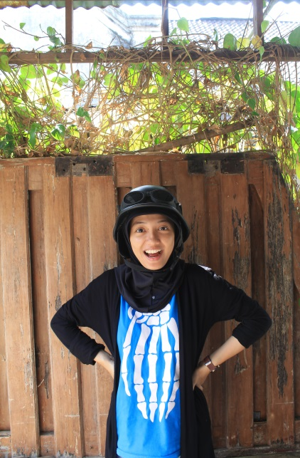

Curiculum Vitae

Dinda Permata

Female, 19th years old

Tarakan, 17-10-1996

Hamid Rusdi Street 141 A, Malang, East Java, Indonesia

**Phone** 085331498830 | **Email** dndpermata17@gmail.com

**LINE** @dndpermata | **TUMBLR** dndpermata.tumblr.com

**EDUCATION (formal)**

2001 – 2002

TK Islam Handayani Tarakan

2002 – 2008

SD Patra Dharma 1 Tarakan

2008 – 2011

SMP Negeri 2 Tarakan

2011 – 2014

MA Negeri 3 Malang – *Major Science*

2014 – now

University of Muhammadiyah Malang – *Communication Science*

**EDUCATION (informal)**

Jemari Indonesia Muda

Seminar of “Indonesian Youth Conference” 2013 - Jakarta

Seminar of “Talkshow Kebangsaan” 2014 – Law Faculty of Brawijaya University

Seminar of “How To Be a Photographer” 2014 – University of Muhammadiyah Malang

**EXPERIENCE**

2011 – 2014

Reporter and Editor of InsanMagz - Journalistic in MAN 3 Malang

2012 – 20133

Chief of Journalistic Divition of OSIMA in MAN 3 Malang

2014 - 2015

Chief of Public Relation Divition of Jemari Indonesia Muda

2014

Committee of Seminar “EVOLVE” - Media Relation Section

2015 - now

Social Media Strategist and Community Manager - Kabar Malang

**SKILLS**

Microsoft Office (Ms. Word, Ms. Powerpoint, Ms. Excel)

Writing

English language

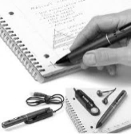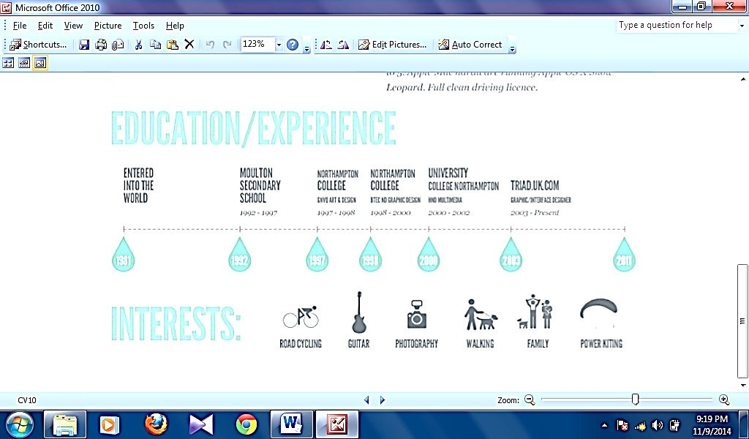**INTERESTS**



CYCLING READING JOURNALISM WRITING TRAVELLING