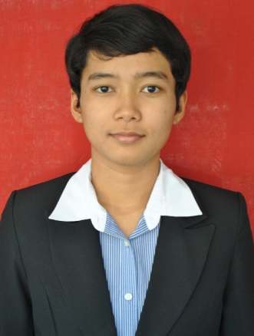

Aluh Lidya Tania, M.Si
Jl. Babakan Lebak RT 02/05 no 46, Kelurahan Balumbang Jaya, Bogor
Phone : (0370) 642869/ 081285823337
E-mail : lidyatania07@yahoo.co.id

CURRICULUM VITAE

- Name  - Date of birth  - Sex  - Religion  - Status  - Address  - Telephone no.  - Mobile no.  - E-mail | :  :  :  :  :  :  :  :  : | Aluh Lidya Tania  Mataram/ 29 September 1990  Female  Islam  Single  Jl. Babakan Lebak RT 02/05 no 46, Kelurahan Balumbang Jaya, Bogor  (0370) 642869  081285823337  lidyatania07@yahoo.co.id

FORMAL EDUCATION
UNIVERSITY | MAJOR | YEAR
Institute of Agricultural Bogor  Thesis tittle :  Study the Impact of Activities Madak on the Ecosystem Intertidal in Intertidal Regions Coastal Green Stone, West Sumbawa | Management of Coastal and Marine Resources | 2013-2014
Fisheries University of Jakarta, Jakarta  Skripsi title :  “Komunitas Biota Yang Berasosiasi Pada Reef Ball Di Teluk Benete, Sumbawa Barat“  GPA : 3.10 | Water Resource Management Technologies | 2008 -2012
High School 2 Mataram | IPS | 2005 – 2008
Junior High School 6 Mataram | - | 2002 – 2005
Elemetary School 5 Mataram | - | 1996 - 2002

NON-FORMAL EDUCATION
TRANING | AGENCY | YEAR | LOCATION
Development World Fisheries and Aquaculture | Bogor Agricultural University | 2013 | Bogor
Assessment of Environmental Impact Assessment | Central Environmental Assessment, Fisheries and Marine | 2012 | Jakarta
Preparation of Environmental Impact Assessment Documents | Central Environmental Assessment, Fisheries and Marine | 2012 | Jakarta
Reclamation of Coastal Areas and Small Islands | Kementrian Kelautan Perikanan | 2011 | Jakarta
Methods of Sampling and Data Analysis Biolimnologi | Restoration of Fish Resources Research Center | 2010 | Jatiluhur
Open Water Diver | Scuba School International | 2009 | Lombok
Latihan Dasar Kedisiplinan | Fisheries University of Jakarta | 2008 | Jakarta

ORGANIZATION EXPERIENCE
Organization | Year | Position
UKM (Unit Kegiatan Mahasiswa) Universitas IPB | 2013-2014 | Member
Albacore (Unit Kegiatan Mahasiswa)  STP Jakarta | 2008- 2012 | Chairman
SMANDA team  SMA Negeri 2 Mataram | 2005-2008 | Coach
Young Hero team  HERO Basketball team | 2005-2008 | Chairman
SMANDA team  SMA Negeri 2 Mataram | 2005-2008 | Chairman
OSIS (Organisasi Siswa Intra Sekolah)  SMP Negeri 6 Mataram | 2005 | Chairman
SPENA team  SMP Negeri 6 Mataram | 2002-2005 | Chairman

SKILLS
Language | Indonesia, English
Computer (Software) | Microsoft Word,Microsoft Excel,Microsoft Power Point

ACHIEVMENT
Championship | Year | Rating
Pekan Olahraga Kota (PORKOT) | 2009 | 2
MBC CUP | 2008 | 1
HERO CUP | 2007 | 1
SMANSA CUP | 2007 | 2
Walikota CUP | 2007 | 2
STMIK CUP | 2007 | 3
Pekan Olahraga Provinsi (PORPROV) | 2006 | 1
Pekan Olahraga Daerah (POPDA) | 2005 | 3

