 | CURRICULUM VITAE
Bestarivi Hastoto | PERSONAL DATA
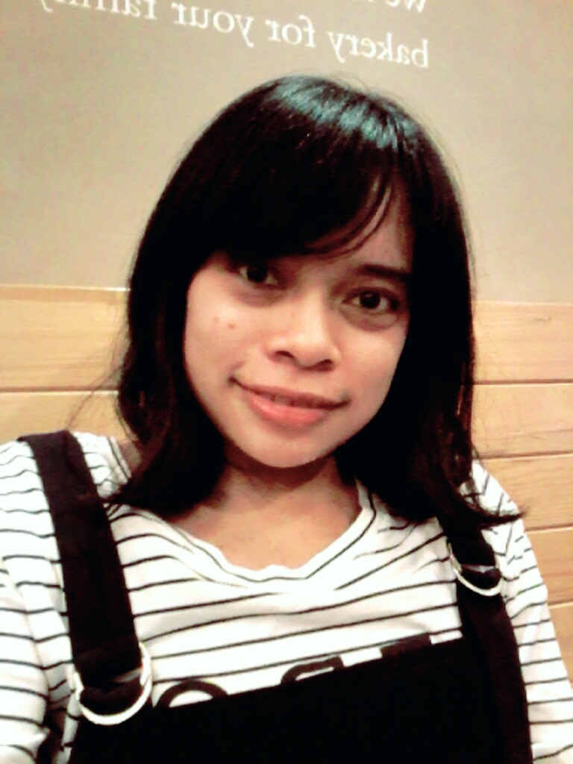 | Nickname : Ivi  Place, Date of Birth : Jakarta, 06 September 1990  Age : 25 Years Old  Sex : Female  Nationality : Indonesia  Religion : Moslem  Mobile : 08131 63 68 872 | 08131 10 10 384  Phone : 021 – 847 3381  Email : song.ivy90@gmail.com  Address : Perum. Bukit Kencana 3 Blok AR No.9.  Pondok Melati, Bekasi

personal characters
I am communicative person, honest, on time. I have capability to work as well as being part of team or as individual. I ever write script for project assigned in class. I ever been write a blog about Korean artist. I want to learn, creative, self organized, and also a good team player.

Education background
University of Paramadina
2008 - 2012

SMA Hutama
2005 - 2008

SMP Angkasa
2002 – 2005

informal education
April 19, 2012
Workshop “Akademi Indosiar 2012 (Sukses Berkarir di Dunia Televisi)”

February 07, 2012
Workshop “Topik Citizen Journalism ANTV”

November 15, 2011
Participation in soft skill training “Kompetensi & Networking”

October 26, 2011
Participation in soft skill training “The Secret of Success: Sukses Sekarang dan di Masa Depan”

July 05, 2011
Workshop “Announcing Skill”

May 09, 2011
Participation in seminar “Youth Political Outlook 2011” at University of Al-Azhar, Indonesia

May 06, 2011
Participation in talkshow “Learn from The Experts Cinematography Clinic with Nia Dinata”

April 05, 2011
Participation in talkshow “Learn from The Creative Writer with Raditya DIka”

March 2011
Workshop “Interpersonal Communication Skill”

2009
Workshop “Persiapan Masuk dalam Dunia Kerja”

2003 - 2004
English Course at ILP, Pondok Gede

working experiences
- Creative | MNC Lifestyle
June 16, 2013 – January, 13 2016
Job’s Description :
- Writing script
- Reporting
- Dealing Artist for interview their daily life
- Shooting for special program

- Creative (Freelance) | MNC Lifestyle
March 10, 2013 – June 10, 2013
Job’s Description :
- Writing Script
- Shooting for regular and special program
- Brief host
- Reporting

- Creative | PT. Cakrawala Andalas Televisi (ANTV)
Purpose : Internship
Periode : August 2011 – Oktober 2011
Job’s Description :
Check schedule artist for guest stor on Triangels programme
- Booking artis and equipment for shooting
- Create production book for programme Triangels
- Create ideas for programme Triangels and any pilot programme
- Writing script for programme Triangels and other pilot programme
- Making rundown for programme Triangels and other pilot programme
- Crew call

experiences
February, 2012
Winner of “Topik Citizen Journalism ANTV”

January 2011 - February 2012
Organization in KOMIK (Komunitas Ilmu Komunikasi) at Paramadina University

September 2011
Committee of “Paramadina Living Values (Be Honest Be Success)”

April, 2011
Committee of “Feel Your Bike with Anies Baswedan”

November 2009
Committee of Talkshow “Respect Other Respect Yourself”

skills
- Computer Literate: MS. Word, Excel, Power Point
- Internet Literate
- Writing Skill

