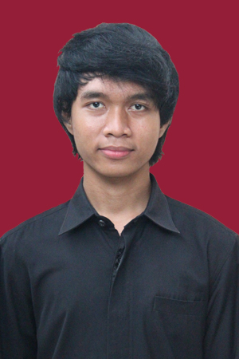
Hasan El Jabir

Address : Bambu Apus Kencana C2, South Tangerang
Birth : Polewali, 03 Januari 1996
Sex : Man
Marital Status : Single
Phone : 087881538477
E-mail : hasaneljabir@gmail.com

Education and Course
2013 : TOEP Score 470 (Good Category)
2014 - Now : Student of Gunadarma University, Informatics Engineering Department
2013 – 2014 : Student of Jakarta State University, Psychology Department
2010 – 2013 : MAN 4 Jakarta
2007 – 2010 : SMP Muhammadiyah 22 Pamulang
2002 – 2007 : SDN Bambu Apus 2
2001 – 2002 : SDN Tanro Polewali

Computer Skills
- Can use HTML
- Can use Delphi (Pascal) Language
- Can use Ms. Visual Basic 6.0
- Can use Oracle
- Can use SQL
- Can use Python Programming Language
- Can use Java Programming Language
- Can use Corel Draw
- Can use Adobe Photosop
- Can use Microsoft Fox Pro
- Can use DBASEIV
- Can assemble computer hardware
- Can do OS and Software installation
- Can operate Ms. Word, Power Point, Ms. Excel, Ms. Access

Organization
2008 – 2009 : Member of Ikatan Pelajar Muhammadiyah
2010 – 2011 : Co-Leader of Kelompok Ilmiah Remaja (KIR) MAN 4 Jakarta
2010 – 2011 : Public Relation of Pramuka MAN 4 Jakarta
2011 – 2013 : Member of KIR MAN 4 Jakarta
2011 – 2012 : Member of Pramuka MAN 4 Jakarta
2011 – 2012 : Member of Kebumian MAN 4 Jakarta
2011 – 2013 : Member of Paskibra MAN 4 Jakarta

Committee Experiences
2010 : Committee Leader in Star Party KIR MAN 4 Jakarta
2011 : Committee Leader in Lomba Karya Tulis Ilmiah (LKTI) KIR MAN 4 Jakarta
2012 : Public relation in KOMPAS Paskibra MAN 4 Jakarta
2012 : Security coordinator in Birthday of MAN 4 (BOFMAN)

Other Experiences
2012 : 1st place in PBB Paskibra Sonic Linguistic MAN Insan Cendekia
2012 : 1st place in Cerdas Cermat Pramuka Kemah Ramadhan Cibubur

Other Experiences
2012 : 3rd runner-up in PBB Paskibra Competition DKI Jakarta
2011 : Finalist in Lomba Karya Tulis Ilmiah (LKTI) DKI Jakarta
2013 : Gifted student in Paskibra MAN 4 Jakarta

