Nur Annisa Syarif
Komp.Permata Sindang Panon, Blok B6 no.24
syarifnurannisa@gmail.com
Bandung, March 2016

Mr. /Mrs. HRD

Dear Mr/Mrs. HRD,
I am writing to express my interest for the position that currently available at your company. I think that I am an excellent for this position, given my extensive background in English education and art, and Basic Accounting, and also my experiences as staff administration at PT. Feng Brother. I believe that my skill and qualification prove my ability to fit that role.
Please see my resume for additional information.
I can be reach anytime via email at syarifnurannisa@gmail.com or my cell phone, 089652063976/087722424280.
Thank you for your time and consideration. I look forward to speaking with you bout this employment .

Sincerely,

Nur Annisa Syarif

Personal Data
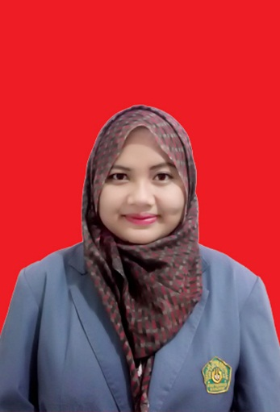

Name : Nur Annisa Syarif
Birth Place/Date : Indonesia, Bandung 7 june 1993
Nationality : Indonesia
Religion : Islam
Addres : Komplek Permata Sindang Panon (Panca Puri) Blok B6 No.24 RT.06 RW. 15 Desa Sindang Panon, Kec. Banjaran, Kab. Bandung, 40377.
Phone Number : 087722424280/089652063976
Email : syarifnurannisa@gmail.com

Summary
Graduated from STKIP Siliwangi Bandung with Honor Degree in English Education Study Program Language and Art Department. I am extremely Objective and Productive, have good attitude, kind, communicative, diligent, tolerant, target oriented, and be responsible. Completed short course of Basic Accounting. Fluent in English and Bahasa Indonesia. I am also computer literate and my software skill include Microsoft Office, Excel, and Power Point.

Education

STKIP SILIWANGI BANDUNG
2015| Sarjana Pendidikan
- Sarjana Pendidikan Bahasa Inggris: English Education and Art

SMA 6 CIMAHI

2010
- SMAN 6 Cimahi, IPS 2010

SMPN 23 BANDUNG

2007
- SMPN 23 Bandung, 2007

SDN Cijerah Indah

2004
- SDN Cijerah Indah 2004

LCC

2011
- LCC (LP3i Course Center), Basssic Accounting, 2011.

Experience
Staff administration, june 2013 – june 2014
PT. Feng Brother | Jl. Melong Asih
Doing administrative work such as making letter, create invoice, financial reports, checking inventory, and reporting stock.

Skills
- Self motivated
- Good English
- Basic Accounting
- computer literate and my software skill include Microsoft Office, Excel, and Power Point.

