Fathan Rohman, S.T
Frontend & Web Developer
CV

Jalan Aminta Azmali Trip No.20, Kota Sukabumi, Jawa Barat
karir.fathan@gmail.com - fathan@ummi.ac.id

Profile | Name : Fathan Rohman, S.T  Gender : Male  Place, Date of birth : Sukabumi, Mei 27, 1994  Citizenship : Indonesia  Relationship : Single  Height, Weight : 167 cm, 75 Kg  Health : Very Good  Religion : Muslim  Mobile number : +62857 2024 7282  Email : karir.fathan@gmail.com
Skills | Codeigniter  Ruby On Rails  HTML  CSS  SCSS/SASS  Jquery  AngularJS  Twitter Bootstrap  Zurb Foundation  Git  Responsive Web Design  Search Engine Optimation  Mobile Version Web Design
Education | SD Negeri rawasalak 2005  SMP negeri 7 kota sukabumi 2008  ma negeri 2 kota sukabumi 2011  University muhammadiyah of sukabumi 2015  FACULTY TECHNOLOGY AND SAINS – INFORMATICS ENGINEERING (S1)
Portfolio | - Symantech Studio - www.symantechstudio.com  - prestige cars indonesia – www.prestigecars.co.id  - STARTUP rumah daku property – www.rumahdaku.com  - p2KFP ummi – www.p2kfpummi.com  - sukabumi kurir express – www.sukabumikurir.com  - dinas ESDM sukabumi - www.dpesdm.sukabumikab.go.id  - green dream mommy – www.greendreammommy.co.id  - dinas perhubungan sukabumi – www.dishub-kotasukabumi.com  - Fakultas sains dan teknologi ummi – www.fsaintek.ummi.ac.id  - C.V batu alam hijau – www.batualamhijau.com  - HIMA teknik informatika – www.hmif.ummi.ac.id  - TOYOTA AUTO2000 SUKABUMi - www.auto2000sukabumi.com  - SKILLAGOGO SOCIAL EDUCATIOn – www.skillagogo.com  - BAPPEDA KABUPATEN TANGERANG - www.bappeda.tangerangkab.go.id  - PT. PRIMA SETYA MAKMUR MANDIRI - www.psmmandiri.co.id  - PT. PUJI LESTARI PURNAMA - www.pujilestari.com

LAMPIRAN WEBSITE COMPANY PROFILE

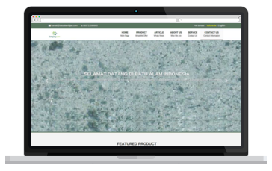

BATU ALAM HIJAU
www.batualamhijau.com

GREEN DREAM MOMMY HERBAL
www.greendreammommy.co.id
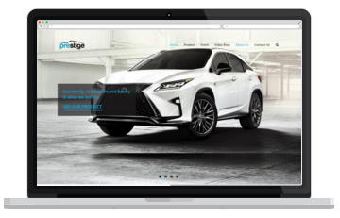

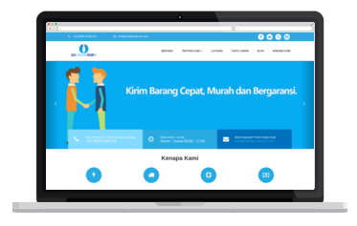

PRESTIGE IMAGE MOTORCARS INDONESIA
www.prestigecars.co.id

SUKABUMI KURIR JASA PENGIRIMAN BARANG
www.sukabumikurir.com

LAMPIRAN WEBSITE STARTUP

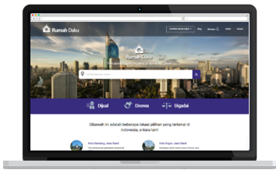

STARTUP RUMAHDAKU PROPERTY
www.rumahdaku.com

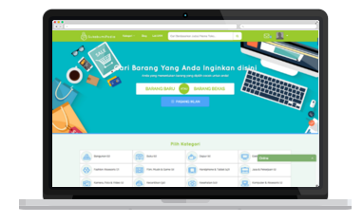

STARTUP SUKABUMIPEDIA MARKETPLACE
www.sukabumipedia.com

LAMPIRAN WEBSITE TOURISM INFORMATION

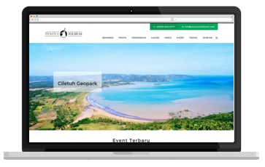

INFORMASI KEPARIWISATAAN PESONA SUKABUMI
www.pesonasukabumi.com

LAMPIRAN WEBSITE UNIVERSITY

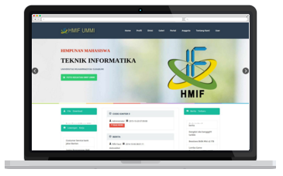

HIMPUNAN MAHASISWA TEKNIK INFORMATIKA
UNIVERSITAS MUHAMMADIYAH SUKABUMI
www.hmif.ummi.ac.id

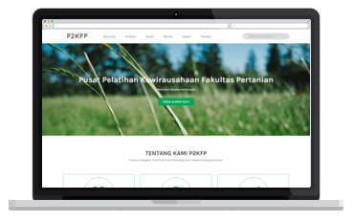

PUSAT PELATIHAN KEWIRAUSAHAAN FAKULTAS PERTANIAN
UNIVERSITAS MUHAMMADIYAH SUKABUMI
www.p2kfpummi.com

LAMPIRAN WEBSITE GOVERMENT

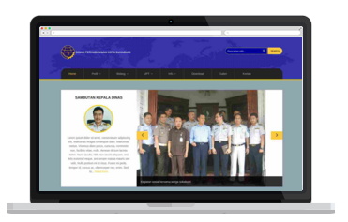

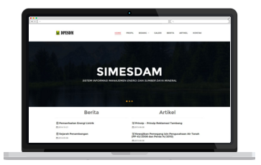
DINAS ENERGI SUMBER DAYA MINERAL
KABUPATEN SUKABUMI
www.dpesdm.sukabumikab.go.id
DINAS PERHUBUNGAN KOTA SUKABUMI
www.dishub-kotasukabumi.com

