CURRICULUM VITAE
GINTARA RIYANDI YUSUF
Personal Data  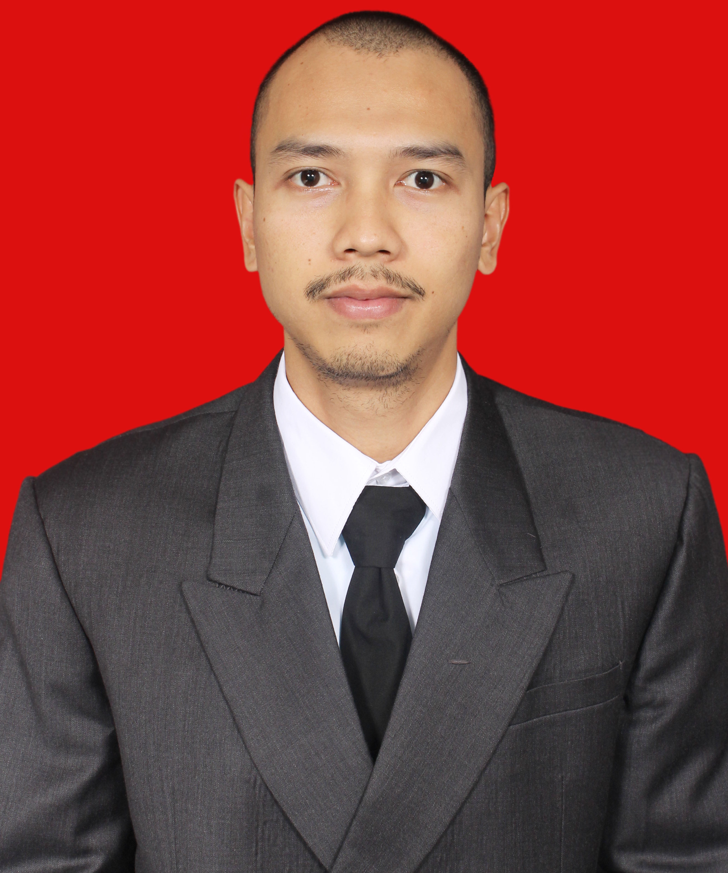 | Home Address : Jl Poris Raya No. 61 RT 001/18, Jatirahayu,  Pondok Melati, Bekasi 17414  Telephone : 08891567642  E-mail address : aghiibho@gmail.com  Place & Date of birth : Jakarta, September 14th,1987  Sex : Male  Marital status : Single  Religion : Moslem  Nationality : Indonesia  Height and Weight : 170 cm / 66 kg  Hobbies : Music, Travelling, Hang-out and Football.
Skills | - Has experiences in broadcasting radio.  - Good understanding in event organizer.  - Good experience in cinematography, photography, advertising, and public relations.  - Responsible, innovative and high initiative in dynamic working environment, hardworking, honest, highly motivated with the ability to work independently as well as a team player, usual work under pressure and good coordination skill toward others.  - Good knowledge with movie and music.  - Fluent in English both oral and writing.
Education | - 2007 - 2014 Graduated from Lampung University Majoring Communication.  - 2003 - 2006 Graduated from SMU 113 Jakarta.  - 2000 - 2003 Graduated from SMP 272 Jakarta.  - 1994 - 2000 Graduated from SDN 09 Jakarta.  - 1992 - 1994 Graduated from Puspa Bangsa Kindergarten Bekasi.
Work experience | - Company : Radio Sonora Lampung  Location : Bandar Lampung, Indonesia  Year : Agustus 2014 – Januari 2015  Position : Announcer, Producer & Script Writer  Responsibilities :  - Announcing at daily prime time program Theshowre.  - Announcing at own program Hipsteria.  - Produces news, selecting music and inviting special guest for Hipsteria program.  - Company : Radio Oz Lampung  Location : Bandar Lampung, Indonesia  Year : November 2008 – Mei 2009  Position : Pre-Announcer, Producer & Script Writer  Responsibilities :  - Practicing and announcing.  - Manage and update radio program Sunday Sport.  - Produces bumper, insert, and smash for radio program Sunday Sport.  - Produces news and inviting special guest for Sunday Sport program.
Course Experience | - Training participant of Advertising 2009 by HMJ Ilmu Komunikasi at Lampung University.  - Training participant of Broadcasting 2008 by HMJ Ilmu Komunikasi at Lampung University.  - Training participant of Photography 2008 by HMJ Ilmu Komunikasi at Lampung University.  - Participant of Study Media Visit 2007 by HMJ Ilmu Komunikasi ( Lampung Post, Chuo Senko, RCTI, Metrotv ).

