RIZKI AULIANISA
085782572078 | rizki.lya@gmail.com | June 13th, 1992 | Cilegon, Banten

Formal Education :
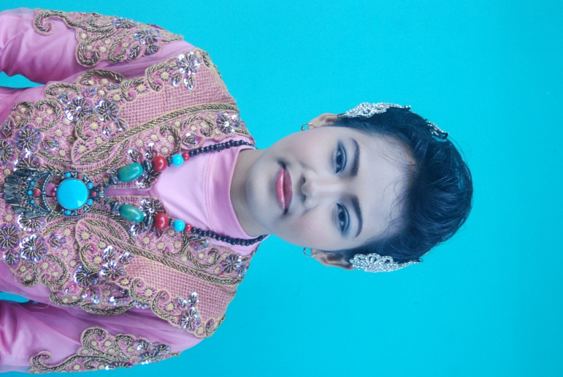
- 2010 – 2015 : Indonesia University of
Education
Study Program : English Language and
Literature
GPA : 3.06
- 2007 – 2010 : SMAN 2 KS CILEGON
- 2004 – 2007 : SMPN 3 CILEGON
- 1998 – 2004 : SDN PABUARAN

Employments :

- Editor Manual & Service Bulletin | Indonesian Airspace (PT. Dirgantara Indonesia) | February – April, 2014 | work hours: 9 am – 3 pm.

Competence :
- English:Literature contents, Grammar, Interpreting, Translating, Analyzing, Summarizing, Correcting, Editing
- Speaking for General, Academic, and Business Purpose
- Translating English – Indonesian, Indonesian - English
- PTESOL/PreTOEFL Score : 527
- Operating Microsoft Office
- Operating Windows Movie Maker, ACD Picture Editor dan PhotoScape.
- Working individually or in group
- Able to work under pressure

Courses/Training/Seminar/Informal Education :
- International Seminar “The Development of the contemporary drama in Indonesia and Norway”, Bandung, 2013.
- Saman dance and Angklung music KABUMI, Bandung, 2011
- English Private, Cilegon, 2008-2009
- LIA course, Cilegon, 2003

Organizational Experiences :
Name | Sponsor | Year |  | Position in Organization
 |  | From | To
English Students’ Association | Indonesia University of Education | 2011 | 2012 | Secretary
KABUMI | Indonesia University of Education | 2011 | 2011 | Member
Library Club | SMAN 2 KS Cilegon | 2008 | 2008 | Member
MPK | SMAN 2 KS Cilegon | 2007 | 2008 | Komisi B Stafff
Economy Club | SMAN 2 KS Cilegon | 2007 | 2007 | Member
MPK | SMAN 3 Cilegon | 2005 | 2007 | Vice Leader
Osis | SMAN 3 Cilegon | 2004 | 2005 | Staff
PASKIBRA | SMAN 3 Cilegon | 2004 | 2006 | Member
Regu Inti Pramuka | SDN PAbuaran | 2001 | 2003 | Vice Leader

Committee Experiences :
Events | Year | Position
Gera Reinkarnasi KABUMI | 2012 | Player
Apresiasi Bahasa dan Seni, English Literature | 2012 | Committee
Farewell Party ESA | 2011 | Secretary
Annual English Contests and Seminar, Indonesia University of Education | 2011 | Committee
KAB (Kaderisasi Anggota Baru), English Students’ Association | 2011 | Committee
Annual English Contests and Seminar, Indonesia University of Education | 2010 | Committee
Engish Literature and Indonesian Literature Competition for Senior and Junior High School in Banten, SMAN 2 KS Cilegon | 2008 | Committee
Art Performance, SMPN 3 Cilegon | 2007 | Secretary
SMPN 3’s 26th Birthday | 2006 | Public Relation
SMPN 3’s Silver Birthday | 2005 | Public Relation

Individuals:
- Hobbies : Listening music, writing diary, hang out, watching football match, online in social media
- Personality: punctual, open-minded, cooperated, easy going, fast learner
- Personal interest: Literature, sports, culinary, photography, music, adventure, traveling

I declare the details stated on this CV to be true and responsible.

RIZKI AULIANISA

