i
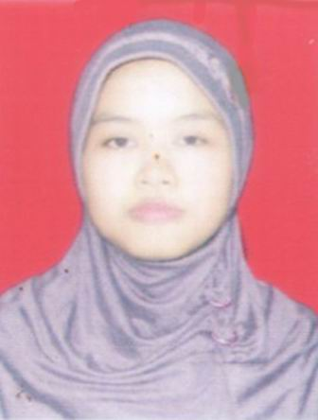Photo

Human Resources Department
Dear Sir/Madam,
On this opportunity, I would like to apply as Officer in your company, my name is Dewi Riani Ningsih,Iam 27 years old, Female, single. I am a Bachelor of Faculty of Letter and graduated from Gunadarma University on October 2009 with GPA 3.24 I would like to have career to expand my experience.
My personality as a hard worker and fast learner type of person would bring benefit to your company. I will be very appreciated if you could give in opportunity to work in your company.
Here with I enclose my curriculum vitae,copy of ID card, copy of Final Certificate, Transcript Academic, Photo, which will give detail of my qualification.
I hope my qualification and experience merit your consideration and look forward to your reply.
Sincerely yours,

DewiRianiNingsih

CURRICULUM VITAE
PERSONAL DETAILS
Name : DewiRianiNingsih
Date of Birth : Sragen, 30 December 1986
Religion : Moslem
Height : 160 cm
Weight : 48 kg
Healthy : Good
Address : JL Raya MawarMerahRt 002/Rw 001 No 1
Jakarta Timur 13460
Phone : 081382053889
Email : Sovelia@ymail.com
PERSONAL EDUCATION
1993 – 1999 : SDN 14 PETANG JAKARTA
1999 – 2002 : SLTPN 194 JAKARTA
2002 – 2005 : SMU MTA SURAKARTA, SOLO
2005 – 2009 : FACULTY OF LETTERS, GUNADARMA UNIVERSITY,JAKARTA
WORK EXPERIENCES
1.PT MNC SKYVISION (INDOVISION) : Nov 2009 to Oct 2010 as Customer Care
2.PT AAG PEST CONTROL : Oct 2010 to Jun 2011 as Service Control
3. BANK EKONOMI : July 2011 to Sep 2013 as Custodian Staff

