Patricia Devina Hendrawan
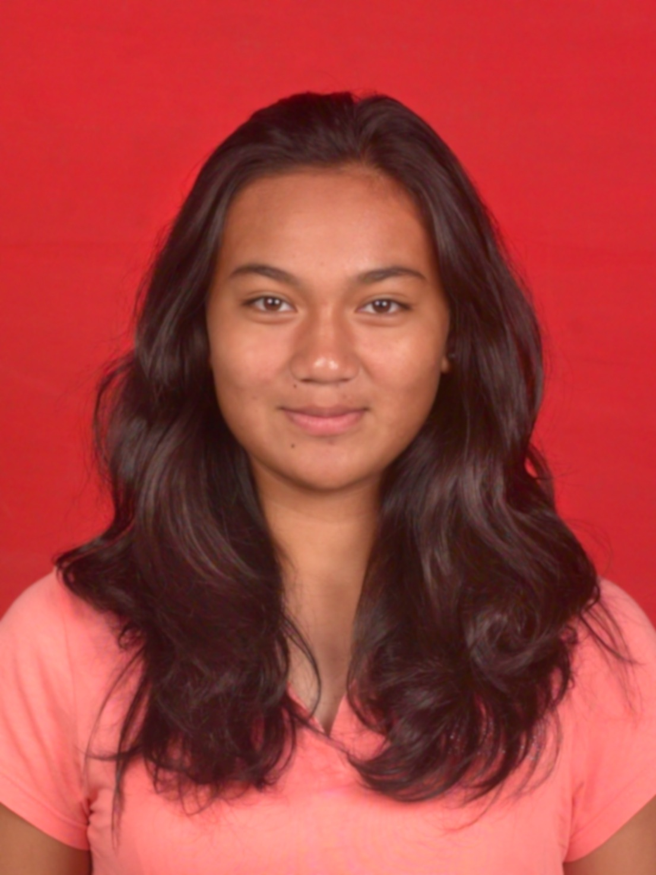 | Jakarta, August 16, 1995  Female  Student  Christian  Indonesian  Komp. Poin Mas B1/17 Jl. Raya Sawangan, Depok 16435  (Currently in Cluster Dalton, Jl. Dalton Selatan 2/1, Gading Serpong – Tangerang 15810)  +62812 87 122133  patriciadevinah@gmail.com

Educational Background

- 2013 – Present, Surya University (Faculty of Clean Energy and Climate Change, major in Environmental Engineering)
- 2010 – 2013, Madania Indonesian School with World Class Standard
- 2007 – 2010, Madania Progressive Indonesian School
- 2001 – 2007, Sekolah Dasar Berwawasan Internasional Madania

Organization Experiences
- Himpunan Mahasiswa Teknik Lingkungan 2013-2014 as Head Department of Activities and Communication
- Head of Surya Diving Club (was Environmental Diving Club) from Department of Environmental Engineering
- Gathering Day of Environmental Engineering 2013 Committee
- An Environmental Day: Back to Mother Nature “Are You A Waste?” 2014 Committee as Publication, Public Relation and Documentation
- Youth and Talk for Renewable Energy 2013 Committee with WWF Indonesia as Publication, Public Relation and Documentation
- Head of Madania Class of 2013 Yearbook Committee
- Madania Alumni Association as Alumni Card Officer
- Garuda Softball Baseball Club as Member
- Paskibra Madania 2009-2012
- Member of Research Center: Center of Sustainable Smart City

Achievements

2014
- 1st Place in Kejuaraan Nasional Softball Open 2014 for DKI Jakarta in Jakarta, Indonesia
- Top 30 of Indonesia Softball Team for South East Asia Games (SEA Games) 2015 Qualification
- 1st Place in Telkom University Softball Cup 2014 for UNISBA in Bandung, Indonesia

2013
- 3rd Place in Asia Pacific and Middle East Softball and Baseball Tournament 2013 (Big League) in Clark, Philippines
- 2nd Place in Indonesia Little League Softball Tournament 2013
- Most Valuable Player in Indonesia Little League Softball Tournament 2013

2012

- 1st Place in Kejuaraan Nasional Softball 2012 (U21) for DKI Jakarta in Manado, Indonesia
- 3rd Place in Architecture Challenge of Energy Champion 2012
- Top 5 in Video Competition of Energy Champion 2012
- Runner-up for the Best Editor in Madania Film Festival 2012
- 3rd Place in South East Asia Youth Baseball Softball Tournament in Perth, Australia
- 3rd Place in Indonesia Little League Softball Tournament 2012 in Jakarta
- 3rd Place in Asia Pacific Softball Tournament 2012 (Senior League) in Jakarta

2011
- Most Valuable Player in Turnamen Pelajar XII (Softball Tournament)
- 1st Place in Turnamen Pelajar XII (Softball Tournament)

2010
- 1st Place in Turnamen Pelajar XI (Softball Tournament)
- Best Pitcher in Turnamen Pelajar XI (Softball Tournament)
- 2nd Place in Asia Pacific Tournament 2010 in Jakarta

Experiences

- Treasurer of Madania Junior High School Yearbook and Graduation 2009
- Highest Profit at Indie Biz (Independent Business) Competition in Madania, 2010
- Edited 2 Movies for Madania Film Festival 2011-2012
- Accomplished 30 Hours of Community Service (Help in free medication and retyping a book for blind people)
- Accomplished 80 hours of Internship, worked in MNC (PT. Media Nusantara Citra Tbk) as a video editor and produced 3 promotional videos for MNC International Channel
- Participant of Video Competition of Energy Champion 2012 held by Energy Efficiency and Conservation Clearing House (EECCHI) and Ministry of Energy and Mineral Resources Indonesia (Kementrian ESDM)
- Participant of Radio Advertisement competition in Energy Champion 2012 held by Energy Efficiency and Conservation Clearing House (EECCHI) and Ministry of Energy and Mineral Resources Indonesia (Kementrian ESDM) 2012
- Participant of Architecture Challange in Energy Champion 2012 held by Energy Efficiency and Conservation Clearing House (EECCHI) and Ministry of Energy and Mineral Resources Indonesia (Kementrian ESDM) 2012
- Participated in Oil and Gas Exhibition in Jakarta Convention Center, Senayan, Jakarta 2012

Description about personal details

I regard myself as a bold, determined, persevering yet a creative person. In view of the fact that I am a perfectionist, my goals are to achieve my duty or assignment in the best result by undergoing a process in my best effort in detail, and also punctual. I am keen to learn new skills and use my considerable ability in doing works. I do love sports, which make me a healthy and active person, yet I get the enjoyment of sitting on the desk, especially in front of the monitor, dealing with softwares like Photoshop and Final Cut Pro. I also consider myself as a good analytical thinker, an open-minded person, having a strong drive for success, and a great willingness to learn. Above and beyond, I act as an “icebreaker” in a team, I dislike a too-serious situation, I like everything done in a fun and enjoyable way, and it does make everything done better.

