C U R R I C U L U M V I T A E

Personal data
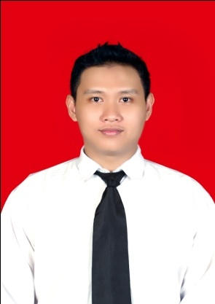
Name : Rudi Saputra
Address : Kedungbulu RT 04 RW VI,
Tambakreja, Kedungreja
Cilacap
Place /Birth of date : Cilacap / December 31st, 1987
Nationality : Indonesian
Religion : Islam
Sex : Male
Marital Status : Single
Telphone number : +6285713323706
Email : rudisaputra8731@yahoo.com

Skills

- Microsoft office knowledge ( Word, Excel, Visio, Power Point )
- English ( Writing and speaking )
- Basic Knowledge in Graphic Software CAD, Solid Work ,Visual Basic and Catia

Education

Formal Education : 2010-now Politeknik Negeri Semarang Majoring in Mechanical Engineering GPA : 3.59 from 4.00 scale
2002-2005 SMA Negeri 1 Kedungreja
Non formal Education :
      - English for basic and intermediate in kurti college (2004)
      - School of basic advocation in branch of PMII, Semarang (2011).
      - ESQ 165 Training
      - WARNA and LDK in POLINES 2010
      - On Job Training at PT. PRIMATEX Indonesia in Boiler Departement 2011
      - Industrial visits to PT. Arkha Jayanti Persada and PT. United Can Company 2012

Strength Points

- I am willing to work hard and can work in a team.
- Creative, Quick Learner and Responsible.
- Willing to work under pressure.

Experiences

- Leader of DPM (department of community dedicated ) PMII Galang Sewu State Polytechnic of Semarang 2010- 2011
- 1st Chairman of PMII Galang Sewu 2011-2012
- Working as an operator in PT.YUTAKA Mfg Ind 2005-2007
- Working as an operator in PT.KAYABA Indonesia 2008-2009
- Working an operator in PT.YUTAKA Mfg Ind 2009-2010
- Polines National Engineering Seminar as a participant 2012
- Seminar of Nahdlotul Ulama as a comitee and participant 2012

Position in Organizations

SMA | Vice Leader Of OSIS | 2004-2005
PMII | Leader of Departement | 2010-2011
PMII | 1st Chairman | 2011-2012

Final project

Design of Three Whell Car Chassis for Paraplegia (Dissable Feet )
Description :
This chassis is part of a three-wheel motor that serves as a buffer in the overall burden. The most fundamental things that become background of chassis manufacturing three-wheel motor for monoplegia (deformed leg one) is the selection of suitable materials with loading and level of comfort and safety of rider, especially people with diable of one feet. The method used in the manufacture of these devices namely literature review, design forms, observations to the workshop to get information about planning and manufacturing chassis. After that, we do chassis manufacturing and testing process to find success planning. And then we have a result that chassis can be used and works as expected in the initial purpose of manufacturing.

About me

I’m Rudi Saputra.I’m first son and I have 2 (two) brothers.My father is a farmer and my mother is a house wife. I had ever worked in manufacturing industry for 4 (four) years. Because of economy crissis, I could not continue working there. Then I decided to continue my study using my savings in state polytechnic of semarang. I have an ideal to make my parent happy and proud of me. I like challanges and adventures and I always think that whatever god gives to me,That’s the best I must receive. I’m a hard worker and I always try to be the best whenever I’am. I have a motto “ Live is only once, make it great and impressive “.

