Curriculum Vitae

MARIANTO
+62 85250277751, aimariant@gmail.com

Jl.Hayam Wuruk GG.Sekuni No.12, Denpasar

AUTOBIOGRAPHY
Place,Date Of Birth  Sex  Marital  Religion  Health  Height  Weight | Banyuwangi, March 10th, 1984  Male  Single  Moeslem  Excellent  160 cm  50 kg

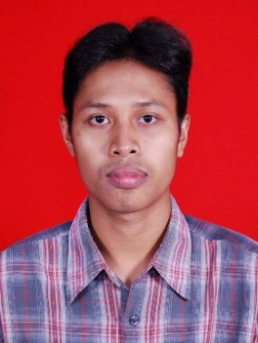

EDUCATIONAL BACKGROUND
1990 – 1996  1996 –1999  1999 - 2002 | Elementary school No.8, Sarongan  Junior High School No.3 Pesanggaran  Senior High School No.1 Gambiran
COURSE AND EDUCATION
2010 | Computer program course, Technocrat collage in Samarinda

JOB EXPERIENCES
2003 – 2005  2006 – 2011  2011 – 2014 | Clerk, Daya teknik In Jakarta  Operator Production, at furniture company Sinar Putra In Samarinda  IT support (Computer Tecnicians), Trisaputra Computindo In Denpasar
ADDITIONAL SKILL
Language  Computer | - English (Passive)  - Indonesia  - Javanesse  - Control of the Hardware and Software  - Know of Networking and Troubleshoot

