Curriculum Vitae

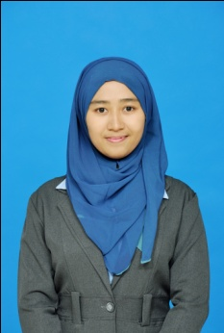
Personal Information
Name |  | Gita Marliyana
Nickname |  | Gita
Place of Birth |  | Bandung
Date of Birth |  | 17thApril 1992
Sex |  | Female
Religion |  | Islam
Marital Status |  | Single
Nationality |  | Indonesia
Home Address |  | Leuwiliang Permai G. 11 RT 01 RW 010 Kec. Leuwiliang Kab. Bogor  Jawa Barat
Email |  | gitamarliyana@ymail.com
Phone |  | 085710302417
GPA |  | 3.51 scale 4.00

Formal Education
Elementary School  1998–2004 |  | SDN 1 Leuwiliang  Bogor, West Java
Junior High School  2004– 2007 |  | SMPN 1 Leuwiliang  Bogor, West Java
Senior High School  2007 - 2010 |  | SMAN 5Bogor  Bogor,West Java
Graduated (S1)  2010 - 2014 |  | Universitas Telkom  Bandung, West Java  Major Study: Accounting

Informal Education
Year : 2012 |  | Sekolah Pasar Modal Syariah Level 1  Bandung, West Java
Year : 2014 |  | Participant of Qualified Internal Auditor (QIA) Tingkat Dasar I dan II  Bandung, West Java

Working Experiences
Year : 2012  ( June - July) |  | On The Job Training (KERJA PRAKTEK) at Bank bjb Cabang Buah Batu, West Java

Organization Experiences
Year : 2010 - 2011 |  | Bengkel Seni Embun IM Telkom  Member
Year : 2010 - 2011 |  | Medical Rescue Commitee  Member
Year : 2011-2012 |  | Bengkel Seni Embun IM Telkom  Head of Project
Year : 2011 - 2012 |  | Medical rescue Commitee  Staff of Social Departmen
Year : 2012 |  | Orientasi Kegiatan Mahasiswa Baru IM Telkom  Medic Division
Year : 2011 |  | Eventainment  Tresurer

Special Skills
Office Applications |  | Microsoft Offices (Word, Excel, Power Point)
Software Application |  | Myob, Accurate, ACL
Internet |  | Mozilla Firefox, Internet Explorer, Opera, Google Chrome
Language |  | Bahasa Indonesia (Excellent), English (Good; TOEFL:440)
Other skills |  | Team work & leadership

The Curriculum Vitae that I have made above is a truth, so if there is any mistake I will be responsible for that.

Sincerely Yours,

Gita Marliyana

