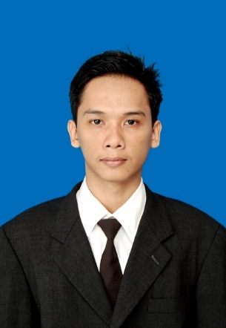
CURRICULUM VITAE

Name : Alfian Chandra Alviana
Date Of Birth : September 17th, 1992
Place Of Birth : Alas
Grender : Male
Nationality : Indonesia
Marital Status : Single
Address : Dusun Kalimango, 002/006, Ds.Kalimango,
Kec. Alas, Kab. Sumbawa, NTB.
Telephone : 087739215995, 082144348884
Email : alfianchandra1792@gmail.com

Educational Background
FORMAL :
- 1999 – 2005 SDN 1 Alas, Alas Sumbawa

- 2005 – 2008 SMPN 1 Alas, Jl. Pendidikan No.128. Ds. Luar, Kec. Alas

- 2008 – 2011 (Field Of study : Networking)
SMKN 1 Alas
Jl. Raya Alas Sumbawa, Kec. Alas

- 2011 – 2014 AMIKOM ASM Mataram
Diploma 3. Information Technology
Graduate with GPA 3.18/4.00

- 2014 – 2016 STMIK AMIKOM Yogyakarta
Bachelor of Information Technology
Graduate with GPA 3.14/4.00

Skills
- Microsoft Office Word, Exel, Power Point, Access & Outlook
- Visual Basic, C#, PHP, HTML, JavaScript, Java, MySQL & SQL Server, Delphi, UML, ERD, DFD, VB.NET, Networking, Software Analys, Jquery, JSON, Network Design, OOP, Data Mining.
- Indonesian (Native), English (Good)

Experiences & PKL
- 2016 PT.MST (Mitra Solusi Telematika) as Enggineer IT

- 2010 STMIK Bumigora Mataram as Enggineer IT Lab

- 2013 PT NNT as employee at Department IT Development.

- 2014 SMAN 2 Mataram as employee Management

