NISA KHOIRIYAH  Kp. Pasar Cadasari RT.03/01 No.19  Pandeglang - Banten 42251  087775134828/08998612920  nisa.khoiriyah@ymail.com | 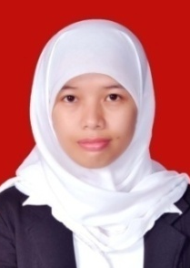
Curriculum Vitae
Skills | - Computer: Ms. Office, Aegisub, Wordfast, Subtitle Edit.  - Language: English and Indonesian.
Education  Membership | Bachelor Degree – Sultan Ageng Tirtayasa University, Serang  English Department – Teachers Training and Education Faculty  2008-2012  Himpunan Penerjemah Indonesia (HPI)/Association of Indonesian Translators  No. HPI 02-14-1076
Experiences | English Teacher at SDN Kurungdahu 1, Pandeglang  July 2009 – August 2009  Teaching English for students in fourth until sixth grade.  English Teacher at SMPN 1 Pandeglang  February 2012 – May 2012  Teaching English for students in seventh and eighth grade.  English Instructor at BBC English Training Specialist Serang  February 2013 – September 2013  Teaching English for children and adults.  Freelance Subtitle Translator at I-Fansub  February 2013 – May 2013  Translating English subtitle into Indonesian for anime, a volunteer.  Freelance Book Translator at Penerbit Indeks  May 2013 – August 2013  Freelance translator for two books (not yet published).  English Teacher at Bimbingan Konsultasi dan Belajar Nurul Fikri  October 2013 – present  English Tutor for High School and Elementary students.

