Curriculum Vitae

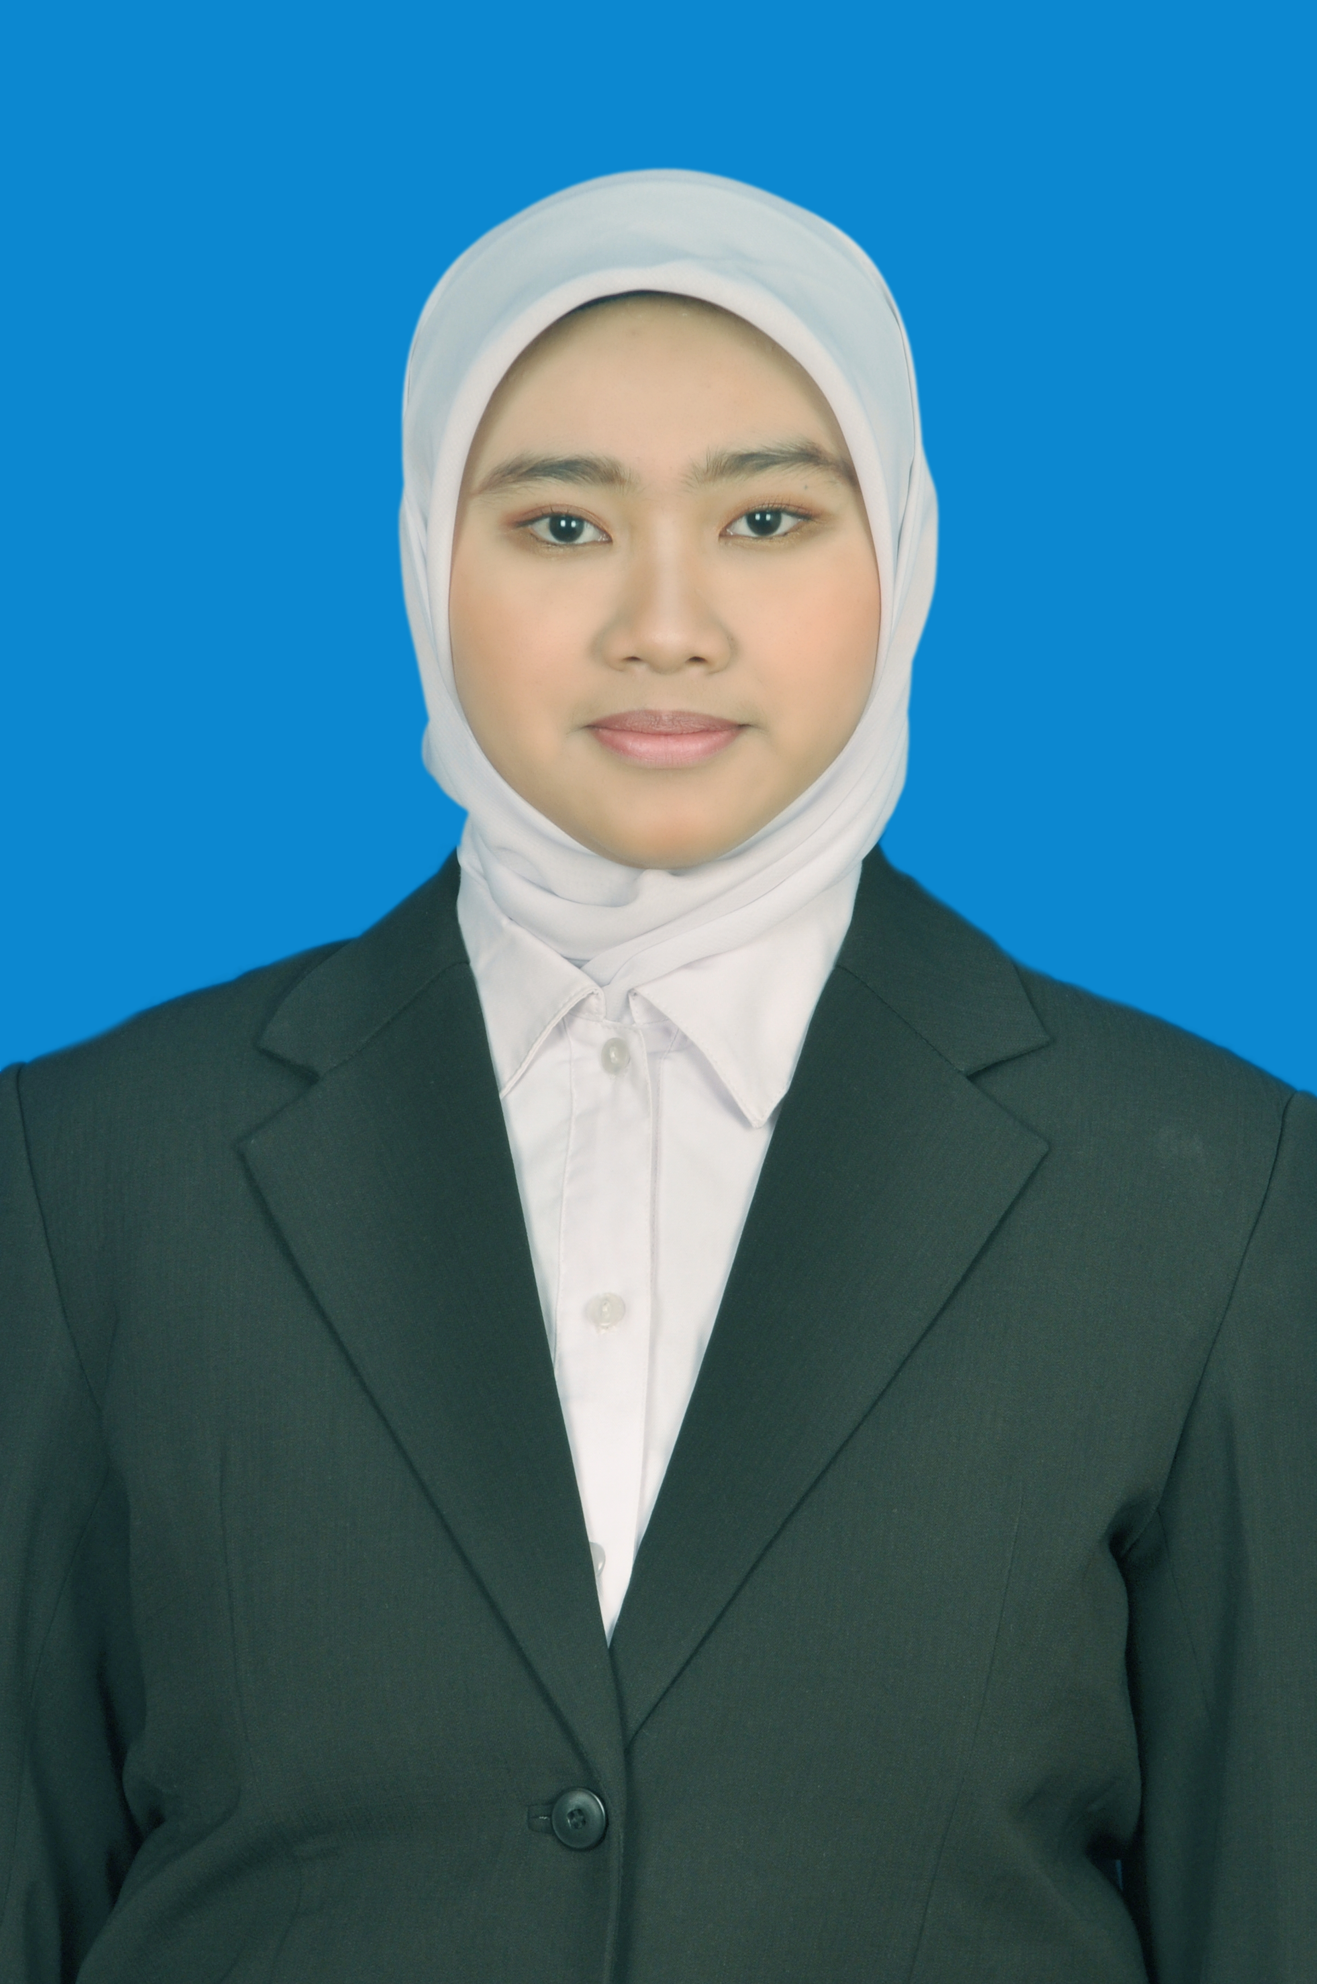
Biographical Information

Name: Devrie Larasati
Date of Birth: October 28, 1992
Gender: Female
Religion: Moeslim
Nationality: Indonesian
Address: Cerbonan RT 02 RW 02 Karanganyar, Surakarta
Phone: 085728848487
E-mail: devrielarasati@gmail.com

Education

Institution Major Degree Date

Universitas Sebelas Maret Education Psychology S.Psi. 2015
Surakarta, Indonesia

Employment Experience

Yayasan Psikologi ANAVA Associate tester 2015 - present

Mitra Optima Assistant of Psychologist 2014 - present

Intelektualita Associate tester 2015

Universitas Atma Jaya Enumerator 2014

Gerindra Data entry 2013

Unit Layanan Psikologi Tester 2013 - 2014
Department of Psychology
Sebelas Maret University

Bintang Study Club Tentor 10/2010 - 03/2012

Research Reports

Larasati, Devrie, Priyatama, Aditya Nanda, Hakim, Moh. Abdul. (2015). Penerapan Token Ekonomi guna Meningkatkan Kehadiran Siswa di Kelas Pintar Rumah Hebat Indonesia. Surakarta : Universitas Sebelas Maret (Skripsi)

Paper Presented at a Conference

2015
Larasati, Devrie, Masita, Anis Diah Ayu, Maharsi, Jannet Cri. (2015). Servant Leadership in Social Community, Peran Agen Perubahan dalam Kehidupan Masyarakat di Surakarta dengan Kepemimpinan Setulus Hati, Seminar Nasional Psikologi UMS, June 13, 2015, Surakarta, Indonesia.

Organization Experience

Rumah Hebat Indonesia Chief Library 2013 – present

Indonesian Psychology Student Coordinator of Research 2013
Association and Development

Himpunan Mahasiswa Psikologi Secretary 2013
Universitas Sebelas Maret
Surakarta

Indonesian Psychology Student Staff 2011 – 2012
Association

Himpunan Mahasiswa Psikologi Staff 2011 – 2012
Universitas Sebelas Maret
Surakarta

