 | Personal Detail
Name | Ageng Satria Kencana
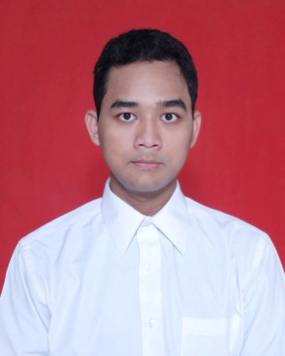 | Address :  Jl. Cempaka III Blok C.14 No. 5-6 Rt.03/07 Perum. Tridaya Sakti 1 Tambun Selatan – Bekasi 17510  Place & Date of Birth :  Kuningan, January 23th 1991  Gender : Male  Religion : Moslem  Marital Status : Single  Hobbies : Music and Movies  Height : 167 cm  Weight : 62 kg  GPA : 3,24  Email : agengsatriakencana@yahoo.com  Phone : 08998903162 / 02188322551

Personality
Able to work both individual and as a team, able to public speaking, having an eager to learn, integrity, discipline and responsible type.
Education
1997 – 2000 SDN Siluman Raya 02
2000 – 2003 SDN Mekarsari 01
2003 – 2006 SMPN 5 Tambun Selatan
2006 – 2009 SMAN 2 Bekasi
2009 – 2013 Al-Azhar University of Indonesia
Faculty : Economy, major : sharia accounting
experience
Accounting (internship)| Kopindosat (Koperasi Indosat)
September – November 2012 Staff in accounting division
Finance| Wonder World Indonesia
July – January 2015 Staff in finance division
(Make journal, invoice, and record all cash and bank
transaction)
skills
- Microsoft Office (excel, Word, Power Point)
- Nuke
Seminar
October 2012 Accounting Seminar, "Audit investigatif: Upaya Pemberantasan Korupsi diIndonesia" Held by Al-Azhar University (certificated)
June 2012 Accounting Seminar, "Implementasi Good Carporate Governance" Held by Al-Azhar University (certificated)
May 2012 Accounting Seminar, "Risk Based Audit" Held by Al-Azhar University (certificated)
April 2012 Accounting Seminar, "Operasional Lembaga Bisnis Real Syariah" Held by Al-Azhar University (certificated)
AWards
Maret 2008 1stchampion of theater in bekasi schools
Februari 2009 3rd champion of band in bekasi schools “ Telkomsel Festival”

ORganizations experience
2006 – 2009 Event Division of Kumpulan Insan Pencinta Apresiasi Seni
(KIPAS)

2013 – 2014 Event Division of Komunitas Anak Jepang Indonesia (KANJI)
Commite experience
2007 Logistic, Festival Band antar SMA se-bekasi
“Kipas Evolution”
2008 Coordinator Event, Festival Band antar SMA se-bekasi
“Kipas Evolution 2”

2012 Coordinator Band, Event community “Gazette night”
at Cic’s Music
2013 Cordinator Band, Event community “Gazette night 2”
at Maitrin Cafe

