CURRICULUM VITAE

Name | Muhammad Fathur Rozi
Nickname | Rozi
Place, Date of birth | Gresik, 01 Mei 1990
Gender | Male
Religion | Islam
Postal address | Jl. Mampang prapatan 6, mampang prapatan, Jakarta selatan
Phone | +6285795822238
Email Address | rozi_its@yahoo.com
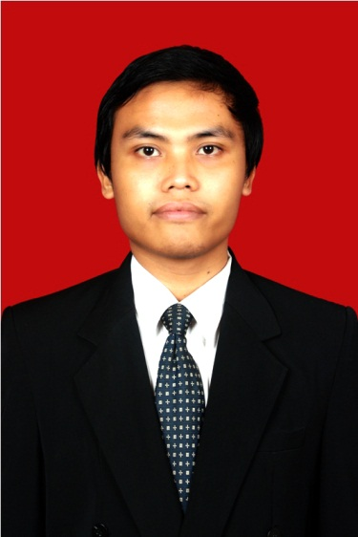
Education
SD | Year | 1996-2002
 | Institution | Madrasah Ibtidaiyah Darunnajah sidokumpul, Bungah, Gresik
SMP | Year | 2002-2005
 | Institution | Madrasah Tsanawiyah Assa’adah Bungah, Gresik
SMA | Year | 2005-2008
 | Instution | SMA Negeri 1 Sidayu
S1 | Year | 2008-2012
 | Institution | Sepuluh Nopember Institute of Technology Surabaya (ITS Surabaya)
 | Department | Mecanical engineering
 | Comulative GPA | 3.12
 | Toefl Score | 490

Skill
Operating system | MS Windows, Linux
Operating software | MS Office, Autocad, Corel Draw, Adobe Photoshop, Fluent, Ulead Video Studio.
Language | Indonesia
 | Inggris
 | Arab

Organization Experience
2006-2008 | PALMAPALA | Internal Staff
2008-2009 | Theater Tiyang Alit | Member
2008-2011 | FORMASI | Head of internal devision
2009-2010 | Himpunan Mahasiswa Mesin | Staff BSO
2010-2012 | Heat Transfer Laboratory | Grader and lab assistant
2011-2012 | Heat Transfer Laboratory | Head of training

Committe Experience
2008 | Bazar mesin at Saturday night | Publication Staff
2008 | Malam keakraban Teknik mesin | Head of Publication
2008 | Pekan mekanika teknik mesin ITS | Equipment Staff
2008 | Wisuda Teknik Mesin 97 | Dokumentation Staff
2009 | Poros Mesin 2009 | Organizing committee
2009 | Mechanical Competition | Equipment Staff
2009 | Latihan Keterampilan Manajemen Mahasiswa pra Tingkat Dasar | Committees
2009 | Wisuda Teknik Mesin 99 | Decorating Staff
2010 | Wisuda Teknik Mesin 100 | Head of decorating committee
2010 | Mesin Games (Tarik tambang) | Head of committee
2010 | Mahasiswa Prestasi | Event coordinator
2010 | Mechanical Competition | Steering Committee
2011 | Mechanical Engineering Care | Event committee
2012 | Buka beersama Alumni SMA N 1 Sidayu | Head of event

Training Experience
2008 | Emotional Spiritual Question | ITS
2008 | Latihan Keterampilam Manajenen Mahasiswa pra Tingkat Dasar | Teknik Mesin ITS
2008 | Pelatihan Karya Tulis | Teknik Mesin ITS
2009 | Latihan Keterampilam Manajenen Mahasiswa Tingkat Dasar | Fakultas Teknologi Industry ITS
2009 | Pelatihan Autocad | Teknik Mesin ITS
2010 | Pelatihan Memasuki Dunia Kerja | Teknik Mesin ITS
2011 | Pelatihan assisten laboratorium perpindahan panas | Teknik mesin ITS
2011 | Pelatihan software Fluent | Teknik mesin ITS

Work Experience
2013-Sekarang | Telkom property | Mechanical engineer

