Curriculum Vitae  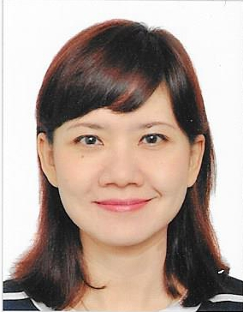  PERSONAL DATA  Home Address  Kavling DKI Blok 156 No.44 Rt.010 Rw.004, Meruya Selatan, Kembangan, Jakarta 11650  Birth Date  January 31, 1973  Marital Status  Married  Mobile Number  +62 817-136-594  E-mail Address  Josaku31@gmail.com  nienna_isilra@yahoo.com  QUALIFICATIONS  Able to operate Microsoft Office  Medium English  Writing, Listening and Conversation | JOIS PITALOKA  PROFESSIONAL EXPERIENCE  Application Access Management Officer  PT.CimbNiaga,Tbk , Jakarta 2008 - 2016  Human Resources Businness Partner Staff  PT.CimbNiaga,Tbk , Jakarta 2006 – 2008  Voice Over Talent (freelance)  Alfa Production House, Alfa Indah, Jakarta 2006  Radio Announcer, Voice Over Talent & Radio Script Writer  PT.Radio Smart Media Utama , Jakarta 2005 – 2006  Dubber  Varashtra Maya Project, Solo, Central Java  General Cashier and Administration  PT.Sriwahana Adityakarta, Solo, Central Java 2001-2004 ( one network link with Diamond Hotel)  Personnel Officer and Junior Marketing  Diamond Hotel, Solo, Central Java, March until June 2001  Engineering Secretary  Quallity Hotel Solo, Central Java 2000 – 2001  Personnel Officer  Quallity Hotel Solo, Central Java 1998 – 2000  Radio Announcer & Radio Script Writer  Jaya Pemuda Indonesia FM Radio, Solo Central Java, 1991-1998  EDUCATION  Bachelor degree in Communication  Slamet Riyadi University, Solo, Central Java  1992 – 1997  High School  SMU Muhammadiyah IV, Solo, Central Java  1988 – 1991  Junior High School  SMPN 124, Duren Bangka, Jakarta 1985 - 1988  Elementary School  SDN 03 Pagi, Mampang, Tegal Parang, Jakarta  1979 - 1985

Copyright information - Please read

© This Free Resume Template is the copyright of Hloom.com. You can download and modify this template for your own personal use to create a resume for yourself, or for someone else. You can (and should!) remove this copyright notice before sending your resume to potential employers.

You may not distribute or resell this template, or its derivatives, and you may not make it available on other websites without our prior permission. All sharing of this template must be done using a link to http://www.hloom.com/download-professional-resume-templates/. For any questions relating to the use of this template please email us - info@hloom.com

