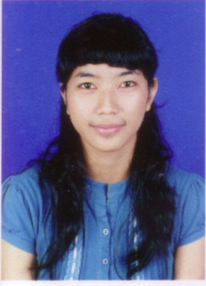

Dear,
HRD Manager
in Place
Dear Sirs,
In connection with the information I received about the opportunity to work at a company that Mr / Ms lead, then I hereby apply for a job as an employee.
My name fitriah Wati, I have a high loyalty, hard working, conscientious, honest, diligent, able to work in teams or individually. Have a willingness to work hard and able to communicate well.
I include this along with curriculum vitae, copy of ID card, copy of diploma and passport photo as much as 1 sheet.
So I have to say this, I hope and will be an award if the application has received a positive response and can be followed up. The attention given and wisdom, I thank you.
Yours sincerely,
Fitriah Wati

CURRICULUM VITAE

Personal Details
Full Name : Fitriah Wati
Sex : Female
Place,Date of Birth : Jakarta, April 25, 1990
Nationality : Indonesia
Address : Jl. Depsos I Rt 005/01 no. 32c
Bintaro, South Jakarta Pesanggrahan
No. Tel : 021-97439274 / 081806648462
Email : vithryah.vari@yahoo.co.id
Educational Background
1. 1996 - 2002 : Bintaro Elementray school, Jakarta
2. 2002 - 2005 : YPUI Junior high school, Jakarta
3. 2005 - 2008 : Senior high school, 15, Jakarta
Working Experience
1. 2008 - 2009 Mc Donald Cust Service
2. 2009 to the current Administrative Receptionist at PT Indosurance Broker Utama
Thus riwat list I've created this life with the true
For your attention let me thank you
I Sincerely,
Fitriah Wati

