CURRICULUM VITAE
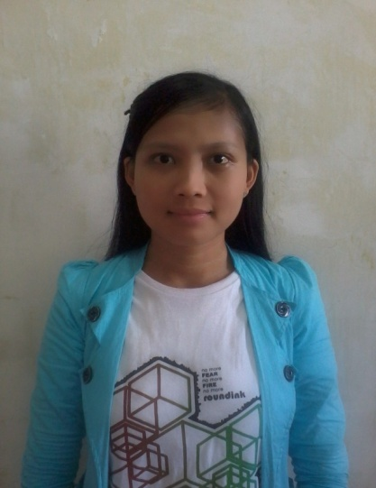
The undersigned below :
Name : Elok Faiqotul
Date of Birth : March 4, 1991
Gender : Female
Address : Perum Kebon Candi Permai G24 Karang Sentul Gondang Wetan
Districk of Pasuruan, East Java
Phone Number : 089 633 043 043
Email : elokfa@gmail.com
Twitter Account : twitter.com/_elokfa
Facebook account : facebook.com/elokfa.heizyi
Educational Background :
- Elementari School Madrasah Salafiyah Safi'iyah Tempurejo Jember (2003)
- Junior High School (SMP) Negeri 1 Jenggawah Jember (2006)
- Senior High School (SMA) Ambulu Jember (2009)
Personal Skill :
- The experience content writer with over 20 websites per day
- Active in a variety of internet social media such as twitter, facebook, google plus (g+) or other Internet community
- Be able to write and review of news online with good
- Ability to Work Independently or as part of a team

Job Experience :
- January 2010 - October 2012 : Operators of Internet Marketing at “ISTANA MEDIA” Jember
This way the curriculum vitae is made by me truthfully and can be responsible.

Your truly,

Elok Faiqotul

