Curriculum Vitae
- Basic Information
Name : Indira Deasita Luthfiani
Nick Name : Dea
Address : Blulukan Timur Raya, Palem Hijau I Blok E1-E2, Colomadu, Karanganyar, Jawa Tengah
Other Address: -
Telephone : 085725646007
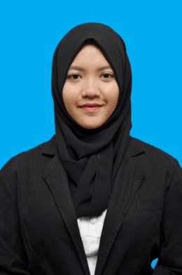
Email : indiradl@rocketmail.com
Nationality : Indonesia
Date of Birth : 7th December, 1994
Sex : Female

B. History of Education
Institution | Years
TK Islam Darussalam Pekayon | 1998-2001
SDN Cipinang Melayu 03 Pagi | 2001-2007
SMPN 255 Jakarta Timur | 2007-2008
SMPN 3 Surakarta | 2008-2010
SMAN 3 Surakarta | 2010-2013
University of Muhammadiyah Malang : Faculty of Social and Politic Science (International Relations) | 2013-present

C. Comitee Experience
Title | Period
Staff Event of School Events held by OSIS | 2010-2013

D. Organizational Experience
OSIS in Senior High | 2010-2013

E. Courses
Title | Period
Table Manner held by University of Muhammadiyah Malang | 2014
France Course Level 1 by KBA University of Muhammadiyah Malang | 2015
France Course Level 2 by KBA University of Muhammadiyah Malang | 2016

F. Skill (Electrical, Computer Abilities, etc )
1. Statistics  2. Microsoft Office  (Ms. Word, Excel, Power Point)  3. Good communication skill  4. Project Management | 5. Human Resource Management  6. Photography  7. Blogging  8. Creative Writing (Poem-Poetry)

