CURRICULUM VITAE

Personal Data
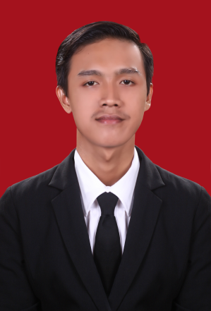
Full Name : Fauzan Adhim
Nick Name : Fauzan
Gender : Male
Place/Date of Birth : Cirebon/ September 07th ,1993
Address : Kemang Ifi Graha , RT 13 RW 07,
Kelurahan Jatirasa, Kecamatan Jatiasih
Kota Bekasi
Cell Phone : 0896-57286370
E-mail : fauzanadhim07@gmail.com
GPA : 3.14
Status : Single
Driving License : SIM C

FORMAL EDUCATION BACKGROUND
Pre School : TK Nurul Yaqin , Jakarta 1998 – 1999
Elementary School : SDIT YAPIDH, Bekasi 1999 – 2005
Junior High School : SAHID ISLAMIC INTERNATIONAL BOARDING SCHOOL
,Bogor 2005 – 2008
Senior High School : SMA Negeri 5 Bekasi 2008 – 2011
Bachelor Degree : University of Semarang State, Economy Faculty, 2011 – 2015
Majoring in Management

SKILL AND LANGUAGE
- Have skill, microsoft office and excel.
- Language: Indonesian and English (Intermediate Competency).
ORGANIZATIONAL EXPERIENCE
Specification | Position | Year
Komunitas Bhinneka Ceria, School and library of peoples Semarang. Comunitee who love and care about education youth in semarang. | Volunteer | 2012-2013

SEMINAR / TRAINING
Seminar/training attended | Seminar/Training Institution | Year
Stock Market Olympiad | KSPM UNSSAF “UNNES Stock Exchange Study Forum” | 2013
National Seminar “Stock Market” | Otoritas Jasa Keuangan (OJK) | 2013
National Seminar “Pemuda dalam arus korupsi dan sejarah.” | BEM FIS UNNES | 2013
Seminar “Radio project, Ayo kerja di radio.” | Pro Alma FM UNDIP, Comunitee radio college | 2013
National Seminar “ Pasar Modal Indonesia Menuju Pasar Modal Dunia.” | STIE PERBANAS, Surabaya | 2014

WORKING EXPERIENCE
Specification | Company | Year
Practical Work Experience in PT JATENG LAND (Jawa Tengah Lahan Andalan) | PT Jatengland | 2014 (On The Job Training)
Junior Sales Executive in PT Astra International Tbk- Daihatsu Sales Operation, Daihatsu Bekasi Branch | PT Astra International Tbk | 2016

