Curriculum Vitae

Mansurni abadi
+62 89631257628, abadimansur25@gmail.com

Hayam wuruk street 115 , kecamatan tanjung karang timur, bandar lampung , lampung

AUTOBIOGRAPHY

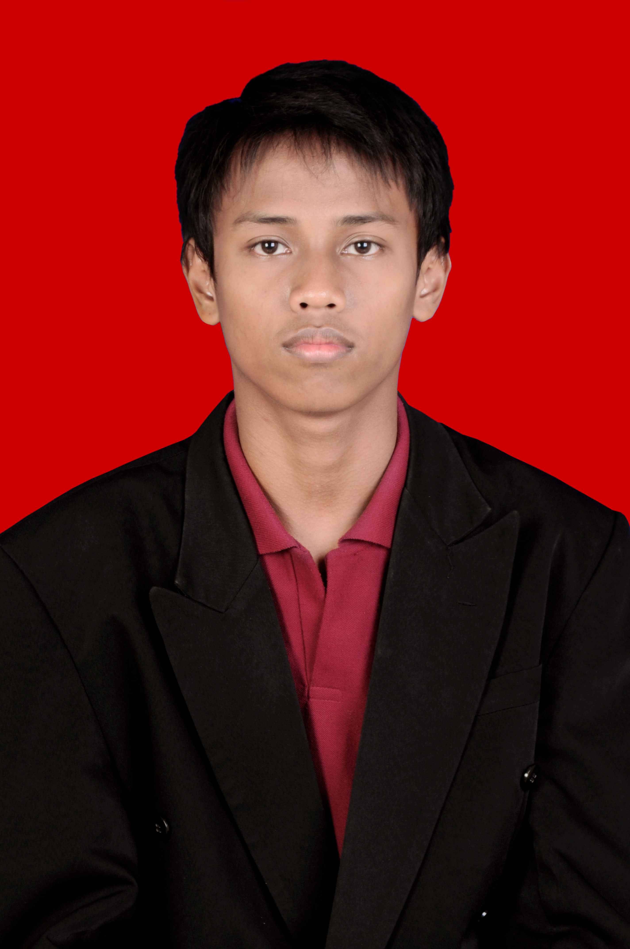
Date Of Birth  Sex  Marital  Religion | Bandar lampung 04-10-1993  male  Single  Islam

EDUCATIONAL BACKGROUND

Formal
2011-2015  2012- .... | Last semester in darmajaya,economic major  Still studying in psychology major in university muhammadiyah lampung ,bandar lampung, lampung, indonesia
Non-formal
2011-2013  2014-....  2015-... | Learn france language in french culture center in bandar lampung  Follow course online in few site free course online like coursera and edx and take course for 6 monts in 2014 learn nlp and psychoanalisis in widi mandiri bandar lampung school for learn nlp ( neuro linguistik programing)  Learn chiness language in china corner in ibi darmajaya

JOB EXPERIENCES

Civil Engineering field
2014-2015 | Therapis autism in pkpb mata hati bandar lampung (teacher and terapis for autism children )
ORGANIZATION ECPERIENCES
2007-2009  2009-2011  2011-2015  2013-2015 | Member of rotaract club surabaya  Member organization muhammadiyah student association  Member of management student association ibi darmajya  Member of psychology studen asosiation in muhammadiyah univeristy  Member of voluntering teaching children in lamda movement is a movement for teach poor children in bandar lampung

ADDITIONAL SKILL
Language  Software | - English (oral and written)  - Indonesia  - Basic in hebrew, german, china, and france , also nederland  - MS Office 2010 and 2007 ( Word, Excell , Power Point )  - Spss  - Dreamweaver and delphi

