ZUAIRIA KURNIA SARI
Jl. Kayu Manis Rt 002/005 No. 10 Condet Balekambang, kramatjati, Jakarta Timur,DKI Jakarta
Phone number : +62 83819964858 (mobile)
e-mail :dzuay18@gmail.com
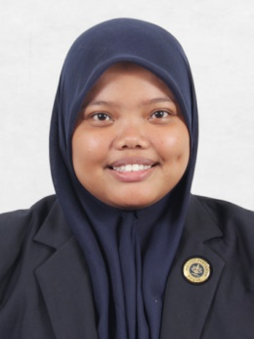
Resume
Place, Date of Birth Jakarta, February 18 1993
Nationalaty Indonesian
Language Skills Bahasa Indonesia, English, Arabic
GPA 3.22/4.0

Formal Education
2011-2013 Bogor Agricultural University ( Diploma, IPB )

2009-2011 SMA LA TANSA

Skills
Programing Language PHP
Database Systems MySQl
Scripting Language HTML, Javascript, CSS, Bootstrap
Framework CodeIgniter
Application Software –Tools Microsoft Office, Microsoft Visio, Macromedia Dreamweaver
Editing Software – Tools Adobe Photoshop, Adobe Premier, Adobe After Effect, Corel Draw
Experiences
Student Intern at The World Agroforestry Centre, Jawa Barat, Indonesia (2014)
Creative Team at ImediaPlus Indonesia, Cibubur, Jawa Barat (2014)

Social Organization
Member Of KAL (2012 –now)

