CURRICULUM VITAE

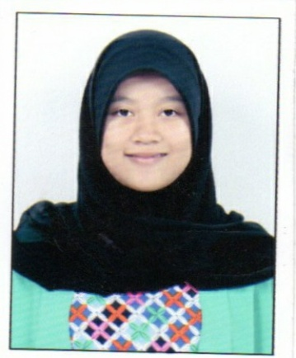
PERSONAL DATA
Name : MILA NURSIVA SITI AISYAH
Place/Date of Birth : Bandung, June 13, 1996
Gender : Female
Permanent Address : Kp. Kebun Kelapa No. 24 RT 01 RW 03
Kel. Cililin Timur Kec. Cililin
Kabupaten Bandung Barat 40562
Phone : 08986439881
Email : mila.nursifa@yahoo.com
Marital status : Single
Religion : Islam

EDUCATIONAL BACKGROUND
Vocational High School 1 of Cimahi, : 2011 – today
Computer and Network Department
Junior High School 1 Cililin : 2008 – 2011
Elementary School 5 Cililin : 2002 – 2008

OTHER INFORMATION
- Trainee at PT. Aplikanusa Lintasarta TB. Simatupang Jakarta : July – Dec 2014
- TOEIC at SMKN 1 Cimahi : May 2014
- Joined Seminar Motivasi Pendidikan BSI : January 2014
- TOEIC International at SMKN 1 Cimahi : December 2013
- TOEIC at SMKN 1 Cimahi : May 2013
- TOEIC at SMKN 1 Cimahi : May 2012
- Member of Kesenian LSP GSP SMKN 1 Cimahi : 2011 – today
- Member of PB. Netha : 2004 – 2005
- Member of PIRMA (Sempoa) : 2001 – 2003

ABILITY

Operating System and Hardware
- Microsoft Windows XP
- Micorsoft Windows 7
- Microsoft Windows 8
- Linux Ubuntu Server
- Linux Ubuntu Desktop
- Mikrotik

Apllications
- Microsoft Office Suite : Microsoft Word, Microsoft Excel, Microsoft Power Point, Microsoft Access, Microsoft Outlook and Microsoft Visio.
- Linux Open Office.Org : Open Office.Org Writer, Open Office.Org Calc, Open Office.Org Draw and Open Office.Org Impress
- Installation Software in Computer
- Installation Operating System in Computer
- Maintenance Computer Hardware and Software
- Instalaltion DNS Server, FTP server, Mail Server, Web Server, Proxy Server.
- Design Web E-Commerce

Working Experience
Trainee at PT. Aplikanusa Lintasarta TB. Simatupang Jakarta : July – Dec 2014
- Instalaltion CCTV Vivotek
- Configuration Vivotek ST7501
- Input Data Base
- Input Portal Logbook
- Making SLA Report

