Creative Freelancer  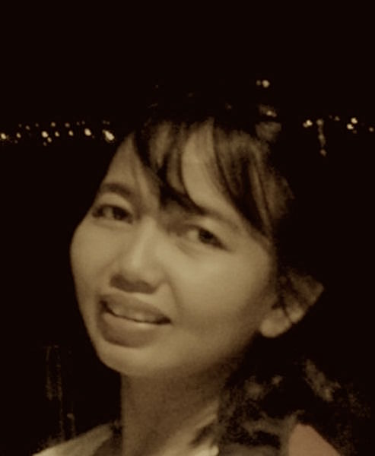  Bumi Malaka Asri 3 Blok G2-9,  Jakarta Timur  +628129220064  my.arisanti@gmail.com  Education  Bachelor of Anthropology  University of Indonesia  1988 - 1993  Course  Basic Graphic Design course  TAFE Brisbane  1997  Assorted Proficient Skills  Proficient in Microsoft office on both Mac and PC platform.  Proficient in copywriting, editing and proofreading. Spare time to do a side job as a content writer and blog writer.  Have a good knowledge about design and layout.  Capable operate Adobe Illustrator, understanding how to operate Photoshop.  Interested and knowledgeable about the art and culture, especially culture of Indonesia.  Get to know me more  FB: Arisanti Kusnanto  Twitter : ars_santi27  IG : ars_santi27  LinkedIn: Arisanti Kusnanto  Portfolio  It will be sent separately | ARISANTI  KUSNANTO  SUMMARY  I am a creative worker with the mind of a strategist and the processes of a leader. I believe my job isn’t my title, it is the responsibilities that I have to do to my clients, my company and my team.  It’s more than 15 year creative career spanning for some of the world’s leading brands, blend innovation with practically and unswerving focus on business results. Dedicated team player with a commitment to high-quality creative work that is on time and on budget.  WORK HISTORY  Associate Creative Director  Havas Worldwide  October 2010 – December 2015  As ACD, I was responsible for raising the bar on the quality of the team’s creative output. Handling local and regional brands, I had to understand the brand’s strategic direction and its competitors, market realities and to ensure each piece of creative is strategically on brief. Led 2 creative team, I was responsible to elevate creative talent in identifying, training and developing successor.  Won several pitching namely Bank Mandiri, Hydro coco, Sakatonik Liver, Britama Junio, Telkom Indonesia, Pizza Hut Delivery, So Good Frozen Chicken.  Clients:  Kalbe: Hydro Coco, Promag, Sakatonik Liver, Entrostop. Konimex: Chocomania cookies, Jescool, Exergy. Vitapharm: Viva, Red-A. Makarizo: Hair Energy, Hair Mask. Nutricia (Regional brand): Nutrilon Royal, Bebelac. Reckitt Beckinser (Regional brand): Dettol all variant, Vanish, Veet, Tiga Roda, Durex, KY Lubricant. Tokio Marine Insurance.  Creative Group Head  Bintang Pratama Communication  July 2006 – September 2010  As Creative Group Head, my job was about leading, creating and managing brands within agency. My Head of Creative already gave me full authority and responsibility to lead two creative teams consisting AD, copywriter, Graphic Designer and Production Personnel. Involved in developing a strong strategic understanding and partnership with Client Service and Planner.  Won several pitching namely Filma Cooking Oil, Asifit and Ciptadent Toothpaste.  Clients:  Sayap Mas Utama: SoKlin Higinis, SoKlin Power, SoKlin Softergent, Zinc Shampoo, Emeron Shampoo, Fres & Natural Cologne, Giv, Ciptadent all variant, Kodomo all variant, Hers Protex.  Others: Filma cooking oil, Asifit.  Copywriter  Lowe Indonesia  May 1999 – May 2006  As Copywriter, I was responsible for generating the words, slogans and audio scripts that accompany advertising visuals then overseeing the production phase. Discussing the client’s core message and target audience with Planner and Client Service. I involved in the research process for new brands.  Winner of Bronze Medal Citra Pariwara for SKIPPY.  Clients:  Unilever: Royco, Blue Band, Kecap Bango, Tara Nasiku, Skippy, Pepsodent Flexy toothbrush, Clear Shampoo, Lifebuoy Shampoo, Domestos Nomos, Domestor cleaner, Wipol.  Others: Procold, XL Indonesia, Bank Niaga, Caxon Enace, Guritos Snack.  Copywriter  Graventa Design  1988 – April 1999  I was responsible for all the works of writing. With ny Creative Head, I created creative concept that speaks compellingly and profitably to a mature market. Also crafted web design, company profile and advertorial to selling that company.  Clients:  Timber Riau Oil Company. Oxford English course, Depdikbud.  Copywriter  Grafik McCann Erickson  February 1995 – April 1997  I was responsible for brainstorming, creating and transforming ideas into words for any ads. Writes words and text for television commercials, radio, jingles and print ads.  Winner of Gold Medal Citra Pariwara 1996 for STARPAGE in Multimedia category.  Clients:  Nestle: Fox, Polo mint, Kokokrunch,  Others: Starpage, L’oreal shampoo, Seiko.  Jr. Copywriter  Domino Design  April 1994 – January 1995  As Junior Copywriter, I started to learn about copywriting, brainstorming and transforming ideas into words for any ads from my senior. Writes words and text for television commercials, radio, jingles and print ads.  Clients:  Gadjah Tunggal tire, HAI Magazine.

