Curriculum Vitae
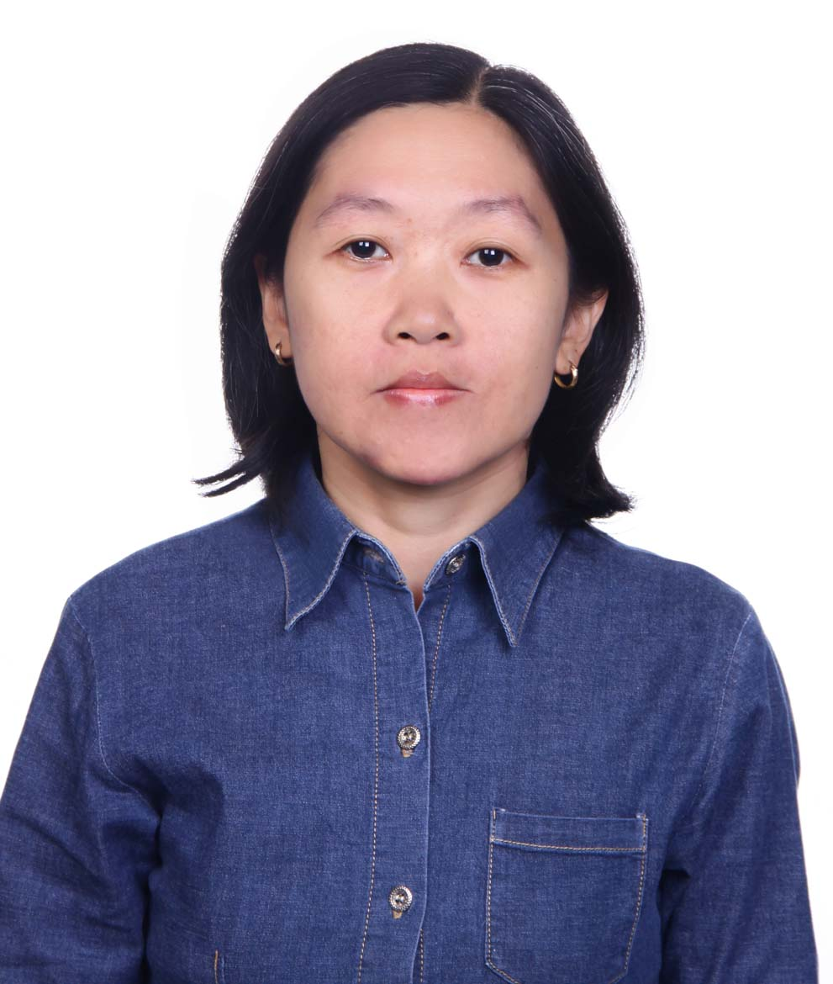 Sugarmini, S.Si
0818 749 205
mini.sugar187@gmail.com
Jl. Paseban Timur IX, No. D187, Salemba, Jakarta Pusat - 10440

NIK : 3171044103721001
Gender : Female
Marital status : Single
Religion : Islam
Place and Date of Birth : Bandung, March 01, 1972
Email address : mini.sugar187@gmail.com, mini313@yahoo.com
Twitter : @minipearl0103
Facebook : Mini Sukanda

Job Experience
January 2002 – April 2014 : Managing Editor of Aneka Yess! magazine
December 2012 – April 2014 : Contributor of www.yess-online.com
January 2002 – December 2012 : Managing Editor of Keren Beken tabloid
2007 – 2011 : Book and Film Editor of B’Girl! fashion magazine
2004 – 2006 : Music and Film Editor of Favorit kid magazine
1999 – 2001 : Reporter of MUMU music tabloid
1998 – 1999 : Math and physic private teacher
1995 – 1999 : Freelance writer for local newspaper in Bandung

Education Background
1998 : S1 Astronomi, ITB
1990 : SMAN 2 Bandung
1987 : SMP Pasundan 3 Bandung
1984 : SDN Cirateun 2 Bandung

Interest
- Book : Fiction and non fiction
- Music and film
- Modern science, especially Astronomy
- Traveling
- Psychology

Miscellaneous
- Author of BigBang The Most Fantastic Korean Boyband Ever – REXA Pustaka, August 2013
- Moderator of Cinta Dari Wamena Movie Talk Show , Jakarta – 2013
- Judge of Yamaha Mio Dream Project 2013 at Bandung, Yogyakarta, and Denpasar

Qualification
- Speaking English fluently
- Fast learner and hard worker
- Easy to adapt and love to try new things

