CURRICULUM VITAE
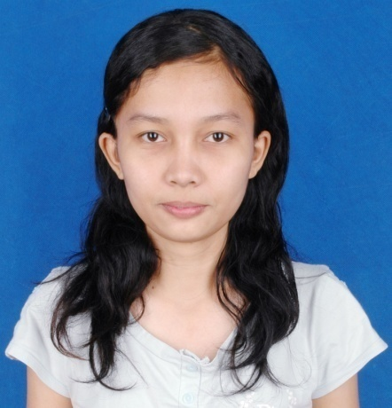
Full name :TettyYuliani ( Yuli )
Address :Kampung Jatimulya Nomor 83, Bekasi
Gender :Perempuan
Handphone : 085777488161/089601906356
Birth Day : 16 Juli 1991
Religion : Christian
Marital status : Single
Email : glorya_julie@yahoo.co.id
PERSONAL PROFILE
A worker who has the responsibility and loyal to the company.I was a young soul who is able to adjust to the situation. I am also friendly, so I can use the talents that I have to work at this company.
CAREER HISTORY
PT. YAMAHA MOTOR MANUFACTURING WEST JAVA  JANUARI 2011 - JANUARI 2013 | Operator  Dutie : supply part to assy line
PT. SANKO GOSEI TECHNOLOGY INDONESIA  APRIL 2013 – AGUSTUS 2014 | Staff PPIC  Duties:  - Handle Petty Cash  - Control Logistik  - Make SO, DO and DN  - Filling Dokumen  - Make schedule delivery supplier and sucbount  - Follow up delivery supplier and subcount  - Control warehouse  - Inventory
ACADEMIC QUALIFICATIONS
- STIE MULIA PRATAMA BEKASI : Accounting 2011-on going ( skripsi )
- SMAN 1 JATIBARANG :sains major 2006-2009
- SMP YOS SUDARSO : 2003-2006
- SD SANTO YUSUP : 1997-2003
- TK SANTO YUSUP : 1996-1997
PROFESISONAL QUALIFATIONS
- Able to use Microsoft Office and Outlook
- Able speak English passive
- Able to use SOFI System
- Able E-SPT

ORGANIZATIONS QUALIFICATIONS
- UKM Oikumene STIE MuliaPratama as member until now
- PMR SMAN 1 Jatibarang as vice chairman period 2008-2009

Bekasi, January 30, 2015

Your faithfully,

TettyYuliani

