CURRICULUM VITAE
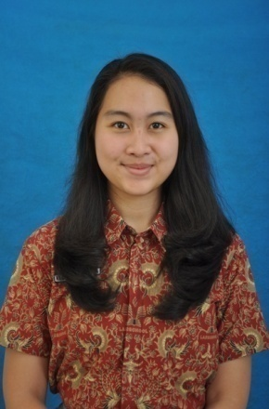
KAMILA NANDA ERIANA
Jakarta, 13 February 1996
Jl. Delman Raya Blok A29 no. 415A RT003/RW011 Kebayoran Lama
Jakarta 12240
087886865948
kamilanandaer@gmail.com

EDUCATION
Formal Education
School/Institution | Level | Year Attended
Faculty of Dentistry, University of Prof. Dr. Moestopo (Beragama) | Undergraduate | 2014 - Present
Labschool Kebayoran Senior High School, Majoring in Natural Science | Senior High School | 2011-2014
19 Junior High School Jakarta | Junior High School | 2008-2011
Muhammadiyah 5 Elementary School | Elementary School | 2002-2008
Aisyiyah Bustanul Athfal 1 Kindergarten | Kindergarten | 2000-2002
Sanggar Kreativitas Bobo | Playgroup | 1999-2000

Informal Education
Institution | Course | Year Attended
Swarna Nusantara Performing Arts Center | Traditional Dance | 2013
ILP (International Language Programs) | English | 2010-2011

WORKING EXPERIENCES
Organizations
Organization | Position | Year
Student Council, Faculty of Dentistry, University of Prof. Dr. Moestopo | Technology, Information, and Communication Section (Member) | Present
Student Council, Labschool Kebayoran Senior High School | Publication and Documentation Section (Member) | 2012-2013
Student Council, 19 Junior High School Jakarta | General Secretary | 2009-2010

Committees
Event | Position | Year
Moestopo Dentistry Scientific Program | Event Staff | Present
Jakarta Movement of Inspirational | Event Staff | 2015
Moestopo Cup Annual and Art | Public Relation Staff | 2015
Sky Avenue | Publication Staff | 2013
Hunting On The Trip | Event Coordinator | 2013
Sky Nation | Publication and Documentation Staff | 2013
Sky Battle | Fundraising Staff | 2013
Jakarta In Global | Publication Coordinator | 2013
19 Cup III : Carousel | Secretary | 2011

ACHIEVEMENTS
- Participated in Realistic Mathematics Olympiad 2007 at STEKPI Jakarta.
- 2nd Place on the highest Final Score (60% National Exam’s score + 40% School Final Exam’s score) at Muhammadiyah 5 Elementary School.
- 2nd Place in Choir Competition 2010 at Pejaten Village Jakarta.
- Participated in the senior high school musical production “Skylite 2012: The Jungle” as a dancer.
- GPA score 3,57 in the 1st semester on Faculty of Dentistry, University of Prof. Dr. Moestopo (Beragama).

SKILLS
- Good in both Indonesian and English Language.
- Good communication and leadership.
- Having good networking with media partners.
- Ability to work in both individual and group.
- IT skills: Microsoft Office (Word, PowerPoint, and Excel).
- Art skill: singing and traditional dancing.

SOCIAL MEDIA ACCOUNTS
- Path: Kamila Nanda Eriana
- Line, Skype, Ask.fm: kamilanandaer
- Instagram, Snapchat, Soundcloud: kamilananda
- Twitter: Kamilanandaer

