CONTACT
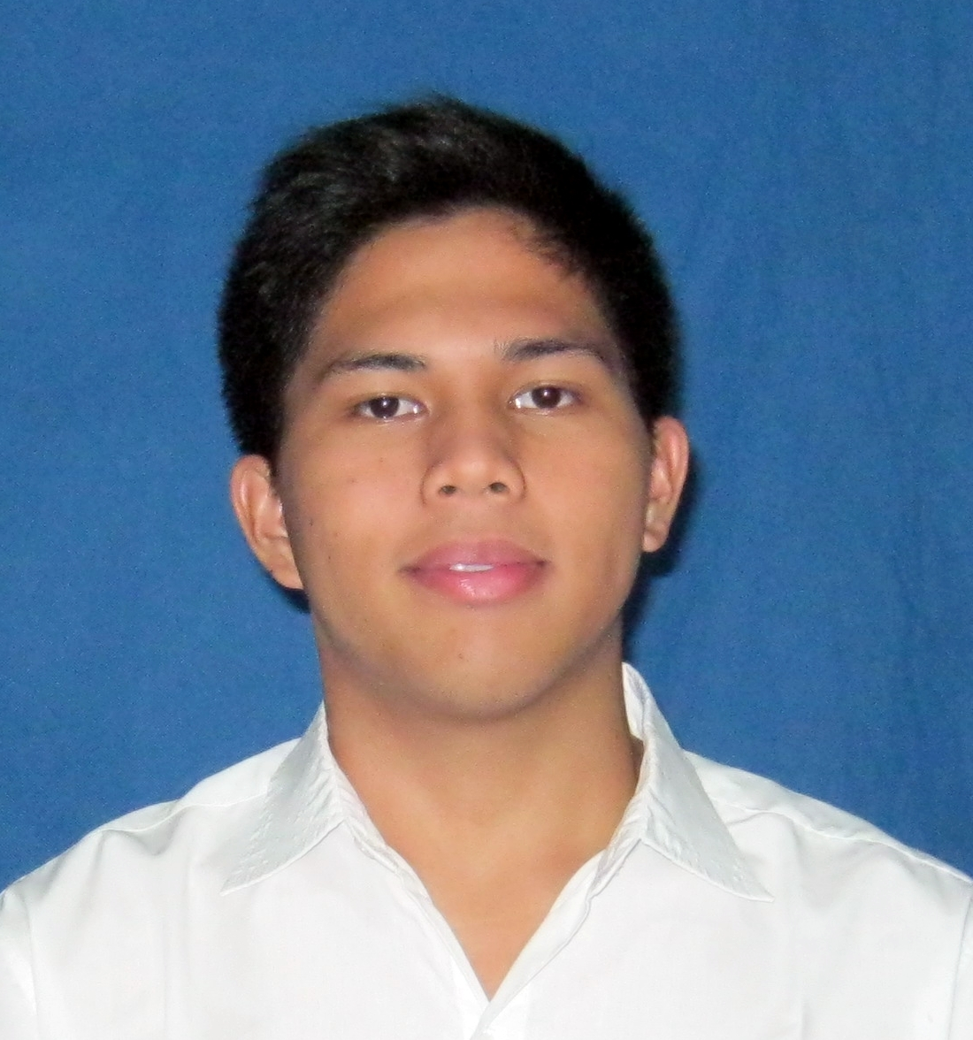
[+62]838-1328-2998
johnhatumesen@yahoo.co.uk
@edojonde
Regency Melati Mas Blok E12/57 Serpong, Tangerang Selatan, Banten

PERSONAL IDENTIFICATION
Jakarta, October 27th 1994
Male
173cm/83kg
Single
Indonesian
Christian
WORK EXPERIENCE

ASSISTANT TEACHER
Palmtrees Montessori School — Serpong | 2014 – present
Work closely managing 30 children. With the target plan.
Prepare the art section, weekly art for children and class decoration

TEACHING ASSISTANT (INTERNSHIP)
乐意居幼儿园 — 广州 | March 2014
Help lead teacher prepare the environment of class
Taught art class

NEWSWRITER AND AUTHOR
HANTAMSAJA.COM — Internet | 2013 – present
Find out what’s happening, write down, post!
Searching for music event to be the media partner

EDUCATIONAL BACKGROUND
广东外语艺术职业学院 - 中国，广州
教育[Training Program] GRADUATED 2014

柳州城市职业学院 – 中国，柳州
Language [Short Course] GRADUATED 2013
SMAN 9 TANGERANG – Kota Tangerang， Indonesia
GRADUATED 2009 - 2012

SKILLS & INTERESTS
KEY SKILLS
GOOD LOOKING ⋅⋅⋅⋅⋅⋅⋅⋅⋅⋅⋅⋅⋅⋅⋅⋅⋅⋅ CREATIVE ⋅⋅⋅⋅⋅⋅⋅⋅⋅⋅⋅⋅⋅⋅⋅⋅⋅⋅⋅ HARDWORKER

ABOUT ME
Being the youngest in my family doesn’t mean that I’m not independent. I love to learn anything in this world. Life is a big mistery, you know. I’m a thinker but it doesn’t mean that I’m not easy-going. I have a lot of friends and I’m really excited to make new friends. I like to do service, because by serving we can share the happiness and spirit of humanism. We also will get to know more about the unique of human-being character. I have a huge passion in art, history, culture and books.

LANGUAGE
BAHASA ⋅⋅⋅⋅⋅⋅⋅⋅⋅⋅⋅⋅⋅⋅⋅⋅⋅⋅⋅ ••••• [Native]
ENGLISH ⋅⋅⋅⋅⋅⋅⋅⋅⋅⋅⋅⋅⋅⋅⋅⋅⋅⋅⋅ •••• [Intermediate]
CHINESE 中文⋅⋅⋅⋅⋅⋅⋅⋅⋅⋅⋅⋅ ••• [Fluent]
FRANÇAIS ⋅⋅⋅⋅⋅⋅⋅⋅⋅⋅⋅⋅⋅⋅⋅⋅⋅ • [Elementary]

ART
MUSIC ⋅⋅⋅⋅⋅⋅⋅⋅⋅⋅⋅⋅⋅⋅⋅⋅⋅⋅⋅ Guitar, Guitar Bass
VISUAL ⋅⋅⋅⋅⋅⋅⋅⋅⋅⋅⋅⋅⋅⋅⋅⋅⋅⋅ Sketching, Painting, Design

OTHERS
COMPUTER ⋅⋅⋅⋅⋅⋅⋅⋅⋅⋅⋅⋅⋅⋅⋅⋅⋅⋅⋅ Ms. Office, Adobe Flash Player, Adobe Photoshop

CERTIFICATES
HSK Level 3 Certificate from 国家汉办
HKC Chinese Conversation 中等 （Intermediate）from 国家语言文字工作委员会
Certificate of Appreciation as Contributor in Garuda Airlines Partnership Gathering from Garuda Indonesia
1st Winner for Scrabble Competition in D’sparted 2011 from SMAN 12 Tangerang
Certificate of Achievement from Perguruan Tinggi Raharja
Certificate of Appreciation as Performers in Indonesia Cultural Night 2014 from Federasi Antar Mahasiswa Indonesia Guangzhou (FAMIG)
Certificate of Appreciation as Performers in RAHASIA from FAMIG
1st winner for Scrabble Competition in English Event 2010 from Mercu Buana University
1st winner as player in Tangsel Basketball Club Cup 2011 from PERBASI Kota Tangsel

