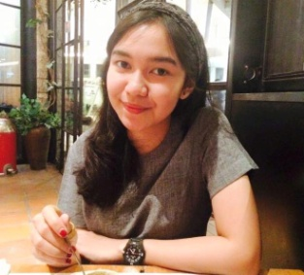
Personal Information:
Name: Nada Inditya Lifa
Gender: Female
Date of Birth: Jakarta, 19 july 1995.
Phone: 083897258848
E-mail: Indi_lifa@yahoo.com / Indilifa@gmail.com

Education:
Status: University Student
Level: S1 / Bachelor
University: Bina Nusantara University
Major: Marketing Communication – Broadcasting.

Qualification:
Languange: Indonesia, English.
Skill: Aftersales, Data Entry, Marketing, Marketing Communication, Online Marketing, Small Bussines Online Marketing, Media Relation, Sponsorhip, Voice Over, Animal Behaviour, Sound, Events Coordination, Public Relation.
Experience:
- Freelance data entry @ PT.Millenia.
- Part time sales assitant @ Cutie cats cafe, Kemang.
- Sponsorship for Seminar Bvoice Magic-o-Radio (goal ZALORA)
- Secretary pro art “Soundsciety” @ MARKAS, tanjung duren.
- Media Relation Bvoice 17th Anniversary
- Media Relation Bvoice 18th Anniversary “EXCAPE”
- Staff Humas (kepanitiaan setahuan Bvoice radio)
- Publikasi & Doc. Team @ Soultyfest.
- Decoration team for Himmarcomm Anniversary @ Gandaria city.
- Registration team @ Bvoice crew recruitment.

