Jakarta, 23th April 2016

Dear Sir/Madam,
Refer to information I knew, I am interested to joint and to contribute with your respected Company.
I am a 27 years of age, and in good health condition. I am graduated from S1 Civil Engineering Education, Faculty of Technology and Vocational Education (Univ. Pendidikan Indonesia) in 2013. I have a good personality. Passion about online/offline maketing, brand awareness, promotion and partnership. Experiences in community, and able to use social media platform, MS Office package such as MS excel, MS Word, MS Power Point, etc.
I am willing to learn and work very well with others and anxious to put my knowledge into practical.
Enclosed is an information of my resume for your consideration. I would be very interested in meeting with you to discuss any possibilities and look forward to hearing from you.

Yours Faithfully,

M. Luthfi Adham Besari

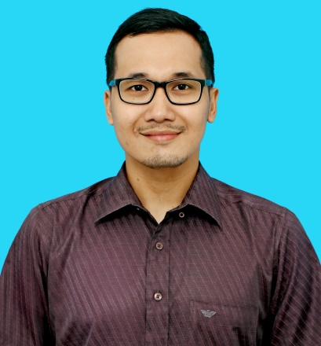
Muhammad Luthfi Adham Besari
Jl. Muararajeun Lama No.29
RT/RW 29/03
Bandung - 40122
Mobile Phone: 082120182942
Email :luthfiadham7@gmail.com
PERSONAL IDENTIFICATION

- Nick Name : Luthfi
- Place/ Date of Birth : Pekanbaru / July 12th 1988
- Nationality : Indonesian
- Religion : Moslem
- Status : Single
- High : 175 cm
- Weight : 70 kg
- GPA : 3,17

EDUCATIONAL BACKGROUND

- Civil Engineering Education 2006 – 2013
Faculty of Technology and Vocational Education, UPI Bandung
- BPI 2 Senior High School, Bandung 2003 – 2006
- 44 Junior High School, Bandung 2000 – 2003
- Tilil II Elementary School, Bandung 1994 - 2000
OFFLINE EVENT EXPERIENCES

- Earth Hour Bandung April 2013
- Project manager “3GP tour” Ge Pamungkas April 2013
(Stand Up Comedy – Bandung)
- Project manager “MESAKKE BANGSAKU” October 2013
Pandji Pragiwaksono (Stand Up Comedy - Bandung)
- SUMPAH PEMUDA 2.0 February 2012
INDONESIA YOUNG CHANGEMAKERS SUMMIT
- Asst. Project manager “MEREM MELEK” April 2012
Ernest Prakasa (Stand Up Comedy - Bandung)
- Earth Hour Bandung April 2012
- Project manager “MERDEKA DALAM BERCANDA” November 2011
Pandji Pragiwaksono (Stand Up Comedy - Bandung)
- TEDx Bandung October 2011
- Volunteer INDONESIA BERMAIN October 2011
- Volunteer SEA GAMES Indonesia November 2011
- Volunteer Workshop KPK “Berani Jujur Hebat” Bandung December 2011

ORGANIZATION EXPERIENCES

- Head of Stand Up Comedy Bandung Community 2012-2014
- Member of Sahabat Walhi (Wahana Lingkungan Hidup), 2011-2013
West Java
- Member of Akademi Berbagi Bandung 2011-2013
- Head of Public Relation Indonesia Youth Development 2010-2011
- Head of Community Development, UPI 2008-2009

WORKING EXPERIENCES

- Freelance Marketing ESL Express 2011 – 2012

- Social Media Strategic & Community Shoutcap 2012 – 2014
https://twitter.com/shoutcap
https://www.facebook.com/Shoutcap
https://www.youtube.com/user/shoutcap

- Talent Management, Kompas TV 2014 – 2015

- Marketing Asisstant PT Shout Network Indonesia 2015 – Present
https://www.shoutcap.net

