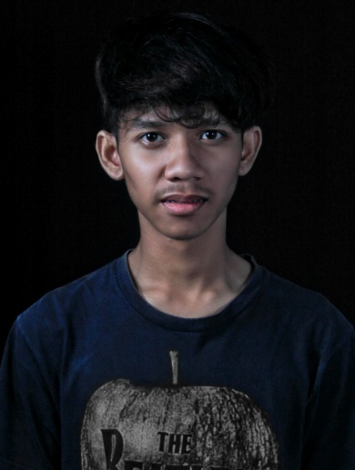

Ervan Muvianto

Personal Information :
Date of Birth : November 4th 1992, Indonesia
Nationality : Indonesian
Religion : Islam

Home/Permanent Address:

Jln.J.Ayani Gg.karet 1 Rw01/05, kecamatan tanah sareal kelurahan tanah sareal bogor,indonesia

Mobile Phone : 089630235866 (private)

Internet mail
Ervanmuvianto@gmail.com

Education:
2009 - 2010: SMK Tri Dharma 2 (Bogor)

Work Experience

Juli 2011 – Desember 2011
Drive Test Engineer
SML, Indonesia

Nature : Contract

Task:
Support for Swap XL 2G Sumbagsel HUAWAI Project

- Perform Drive test with TEMS Equipment
- Proceed log files to MapInfo format to make coverage plot
- Produced Rx Level and Rx Quality coverage plot for drive test report
- Model Tuning measurement
- Final Acceptance KPI
- GPRS Test

Mei 2012 – april 2013
Drive Test Engineer
PT.LINTAS MEDIA TELKOMUNIKASI Indonesia

Nature : Contract

Task:
Support for NPI INDOSAT 3G Jawa Barat ERICSSON Project, TELKOMSEL HUAWEI Project and SWAP ERICSON FOR HUAWEI jawa barat.

- Perform Drive test with TEMS Equipment
- Proceed log files to MapInfo format to make coverage plot
- Produced EcNO and RSCP coverage plot for drive test report
- Model Tuning measureme Vip Complant
- Final Acceptance KPI
- TRX Test
- GPRS Test

Agustus 2013 – Agustus 2014
Drive test engineer
PT.Advantel ,GCI, PICOTAL

Task:
Support for telkomsel 3G HUAWEI Project, indosat 3G,3G , LTE 4G

- Perform drive test with TEMS Equpment and GENEX 4G
- Proceed log files to MapInfo format to make coverage plot
- Produced EcNO and RSCP coverage plot for drive test report
- Model Tuning measureme Vip Complant
- Final Acceptance KPI
- TRX Test
- GPRS Test

Drive test enginering
PT.TORAGA SOLUSI KOMUNIKASI

Task :
Support for Telkomsel 3G and 2G

- Perform Drive test with TEMS Equipment
- Proceed log files to MapInfo format to make coverage plot
- Produced EcNO and RSCP coverage plot for drive test report
- Final Acceptance KPI
- TRX Test
- GPRS Test

RAINSHOOT PHOTOGRAPHY

Task :
Photography wedding and prewedding

- Perform editing photoshop
- Adobe all

Tiga O komunikasi

Task :
Support for Smart Fren Cdma

- Perform Drive Test with CNT & CAN
- Proceed log files to Mapinfo format to maek coverage plot

Tool and Skill Literacy

Hardware Tools
- Tems Family (Classic, Investigation, Optimization)

Software Appliance
- Tems 5,Tems 8.0.3, 8.1.3, 9.1, 10.0.5, 15 , 16
- NEMO HANDLY
- CNT & CAN CDMA
- MCOM 4.2
- Mapinfo 8.5, 9.0 , 10.3
- AutoCAD
- MS Office
- Corel draw
- Adobe Photoshop 4,5,6
- Adobe Light Room 4,5,6
- Adobe Premiere
- Fruty Loop
- Nuendo

PERSONAL QUALIFICATION

Strong interpersonal skill, leadership, ability to adapt in any situation, trust worthy, hard worker, believer in quality and teamwork, self motivated, able to speak English, proactive, have a loyalty, excellent communication skills, and like traveling .
I guarantee that description above is true.

