Josua Tia Mangara Sitohang
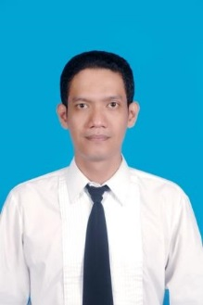
Jl. Gn Sanghyang Bale Residence C 11
Kerobokan Denpasar
Email : josua.tohang@gmail

HP : 0813 3780 0369

Senior Waiter
(Bintan Lagoon Resort 2000 – 2003)
Set Up & Clear Table
Set Up Buffet
Taking Order Food & Beverages

EDUCATION
Stiepar Yapari Bandung DIII
SMA Xaverius I Palembang
SMP Xaverius 5 Palembang
SD Xaverius 8 Palembang

ACHIEVMENTS
Best Employee Bintan Lagoon Resort
Best Employee The Patra Bali

LANGUAGES
English
Indonesia

HOBBY
Photography and Soccer

EMPLOYMENT EXPERIENCES
Assistant Dining Room Steward
(Holland America Line 2008 – 2014)
Table Set Up
Daily Breakfast, Lunch, Dinner Service
Up Selling Beverages
Taking Food & Beverages Order
Full Course Service

Restaurant Supervisor
(Ubud Adventure Center 2013)
Opening Team
Restaurant Set Up
Responsible Opening & Closing
Daily Manning Crew/Staff
Handling Events
Handling Complain
Order to Supplier

Restaurant Supervisor
(Hard Rock Hotel Bali 2005 – 2007)
Restaurant Set Up
Responsible Opening & Closing
Daily Manning Crew/Staff
Handling Events
Handling Complain
Order to Supplier
Daily and Annual Income Report

Waiter/Room Service
(The Patra Hotel & Villas 2003 – 2005)
Clear Up & Set Up Table
Taking Food & Beverages Order

