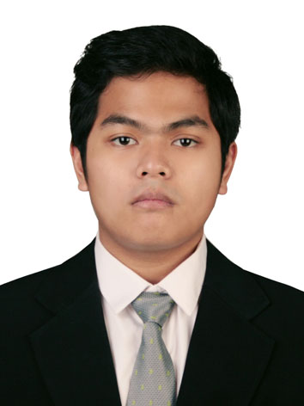

Muhammad Lufthy Oreckel Lukito
Date of Birth: 14 October 1991

Address : Jl. Teknologi 4 No. 12, Meruya Utara – Jakarta Barat
Tel: 021-5851748 / 08558646334
Email: lufthy@gmail.com

Profile

Male – 22. October 14th, 1991
A highly motivated, loyal, fast learner, and cooperative person who has a good communication and management skills seeking for a career opportunity.

education

- Prasetiya Mulya Business School (2009 - 2013)
- 78 International Class Senior High School (2008)

WORKING EXPERIENCES

- Assistant Business Analyst at PT Indosat Tbk. (Sep 2014 – Now)
Situation/Task : Creating and maintain raw database of Company sales.
Action : Creating a design of flow database. Transform thousands of database, then modify it into an easy viewing report. Mainly using Pivottable in Excel.
Result : Bundling Device Report, Sales Daily Tracker, and many more.
- Account Manager at PT Indosat Tbk. (Jun 2014 – Sep 2014)
Situation/Task : Selling products to corporate, maintain needs and problem of existing client
Action : Create monthly selling plan (pipeline), create and report daily sales activities, approaching and selling Indosat IT Solution product to corporate, maintain existing client, develop good personal relationship with client and prospects, Analyze what product that suitable for client. Analyze the the client profit when using and not using indosat products.
Result : Subscriber increase for the division
- Account Executive at PT Informasi Teknologi Indonesia (Jan – Mei 2014)
Situation/Task : Selling products to corporate, maintain needs and problem of existing client
Action : Create monthly selling plan (pipeline), create and report daily sales activities, approaching and selling mobile advertising products to corporate, maintain existing client, solving problem of running project, develop good relationship with client, develop marketing plan for client
Result : Division Revenue Increase, Satisfied client, New client.
- Founder of Idealsitz Garage (2014)
Situation/Task: Create a small car interior garage in BSD Autoparts.
Action: Create, manage and plan a whole management activities at Idealsitz Garage including purchasing, simple financial report, Layout Design, Inventory management, and sales.
Result: a well running car interior garage.
- Chief Operational Officer at UNKL’S DINER (2013)
Situatuion/Task: Create a small American diner near Binus University
Action: Create, manage, and plan a whole operational activities at UNKL’S DINER including SOP, Layout Design, ABC Analysis for inventory management, Purchasing sheet, Process Mapping, and five year Projection
Result: a well running American Diner.
- Community Development in Cianjur, Prasetiya Mulya Business School (2012)
Situation/Task: Lived in Babakan Sari, Cianjur for a month to help develop small business for the family.
Action: Developed Ikan Balita Abah Ganda, a fried baby fish business. Started and taught the family member to run the business, starting from operation, recording the financial transaction, until marketing the product into the market.
Result: The family gained additional income from the business.
- Internship at PT Informasi Teknologi Indonesia (2010)
Situation/Task: Help the supervisor to develop a new mobile software.
Action: Develop a new software that costumer needs, create the concept visualization of the software.
Result: Concept visualization of the Kaskus mobile.
- Social Worker at 06 Elementary School Tangerang (2010)
Situation/Task: Assigned to help the 06 Elementary School as part of the social work.
Action: Taught mathematics, English and other subjects to children in the 06 Elementary School.
Result: The children gained knowledge and fun in their study.

organizational experiences

- Head of Search Autofamily (Autoclub)
Situation/Task : Lead, design, manage, plan, and control of all automotive or non automotive organizational activities. Responsible of all action the whole club.
Activities : Recruit a people, register to many automotive event
Result : We already won many award in many contest, gain a club member (50 People)
- Committee of Automotive Zone in Indonesian Community Expo
- Committee of Indonesian Stance Lovers 2010 – present
- Committee of Mushroom Sega Family 2008 – present
- Committee of Alcatraz Crew 2006 – present

Workshops and trainings

- Workshop with Bong Chandra Entrepreneurial Motivation Seminar

STRENGTHS

- Self confident and fast responsive in doing a job
- Fast learner
- Able to manage myself and time
- Able to work as a team & alone
- A good communication skills
- Creative & a good problem solver

OTHER SKILLS

- Language : Indonesian (mother tongue), English (fluent)
- Music : Guitar, Bass and Drums
- Computer Skills : Expert at Microsoft Office

