Curriculum Vitae

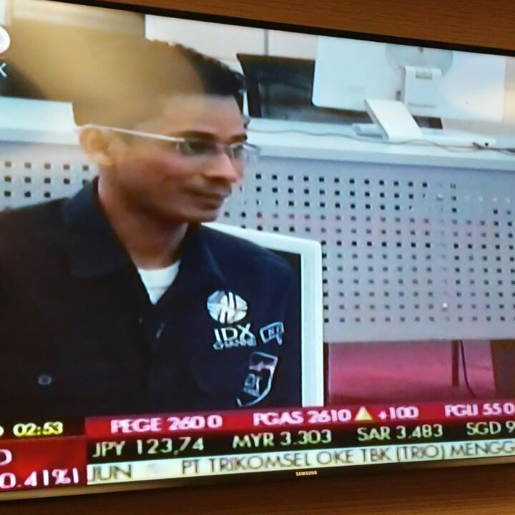

**Novan Dwi Putranto, S.Sos**

I’am 35 years old. Experience as a journalist for 10 years in print media, on line and television with specialties in several sector such as finance, macro economy, oil and gas, mining, energy and politics.

Good communciation and writing skills and work as both team leader or team player.

Conscientious person who works hard and pays attention to detail. Flexible, quick to pick up new skills and eager to learn from others. I also have lots of ideas and enthusiasm.

Graduate from International Relations stuides, Institut Ilmu Sosial dan Ilmu Politik Jakarta 2005, GPA 3.20.

**Contact Details:**

Address: Green Royal Residence Blok A1/5, Bambu Hitam, Cipayung-Jaktim

Phone: 081281830427

Email: [novandwiputranto@gmail.com](mailto:novandwiputranto@gmail.com)

Twiitter: @novanputranto

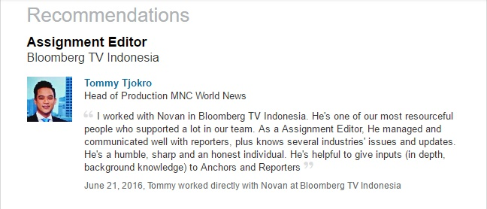 SKILLS

**NEWS WRITING, REPORTING, EDITING**

**ENGLISH –WRITE AND SPEAKING**

**SOCIAL MEDIA, MEDIA ANALIST**

**TELEVISION PRODUCTION, SCRIPT, EDITING** 