Kontak
Address : Jl. Delima Jaya I RT 004 RW 02 NO. 63
Rempoa, Ciputat Timur, Tangerang Selatan
15412
Phone : 0856-7863-754
Email : citraagustiani24@gmail.com
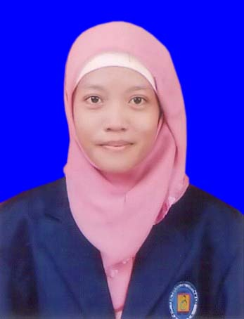

Pengalaman Kerja

01 Maret - 31 Maret 2010 | PT. TELEKOMUNIKASI INDONESIA Government of Ontario  (UNIT BILLING COLLECTION)  Praktek Kerja Lapangan.
01 November 2015 – Sekarang | PT. Adfin Bureau Indonesia  ( Freelence – Entri Data)  Input data berupa nilai dan foto ke dalam sistem airminumstrategis.com
16 Maret 2016 – Sekarang | PT. Denbe Anugerah Solusindo  Admin IT Helpdesk  Ditempatkan di PT. Perusahaan Gas Negara (Persero), Tbk. , Tugas saya Melayani dan menerima permintaan user, meng-entri data dan membuat report.

Pendidikan
1999 – 2005 | SD Negeri 11 Kebayoran Lama Utara Jakarta Selatan
2005 – 2008 | SMP Negeri 161 Jakarta Selatan
2008 – 2011 | SMK Media Informatika Jakarta  Jurusan Multimedia
2011 – 2015 | Universitas Budi Luhur  Jurusan Teknik Informatika

Keahlian

PHOTOSHOP
MS. Office
3D Max
DREAMWEAVER
AFTER EFFECTS
ADOBE PREMIERE

