****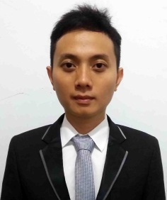

**PROFILE DETAIL**

Name : ANDRI SETIAWAN

Place & Birth Date : Tangerang 16-05-1984

Sex : Male

Mailing Address : Jl. Gn Lumut No. 40 Denpasar - Bali

Nationality : Indonesia

Contact Number : 08788 3271 573

Email : andri.me.setiawan@gmail.com



**EXPERIENCE**

**EDUCATION**

* PRINT MANAGER

(Jan 2013 - Present)

PT MEGA IKLAN – Advertising & Publishing

* SENIOR GRAPHIC DESIGNER (Aug 2011 – Jan 2013)

INDOGRAPHS PRINTING –Design & Printing

* GRAPHIC DESIGN AND IT SUPPORT (Juli 2010 – August 2011 )

CV CREATIVE BALI TRADING–Clothing and Accessories Manufacture

* IT SUPPORT

(Desember 2009 – April 2010)

PT GUNUNG AGUNG SOFTWARE MANAGEMEN –Software Developer

* (2007-2011) **Paramita Indonesia University** - Tangerang, Bachelor of Information Technology
* (1998-2001) **Muhammadiyah 1 Senior High School** - Denpasar
* (1995-1998) **Muhammadiyah 1 Junior High School** - Denpasar
* (1989-1995) **Pinang 2 Elementary School** – Tangerang



**QUALIFICATION**

* Leadership
* Speed
* Multitasking
* Computer Trouble Shoot (Hardware, Software)
* Fluent in English oral & written
* Driver License A & C



**SOFTWARE**

**Scale 1 to 5**

**Word**

**Excel**

**Coreldraw**

**Indesign**

**Illustrator**

**Photoshop**